SECTION C

STATEMENT OF WORK TABLE OF CONTENTS

1.0 Scope

- Services Provided to the Government
  - Lease of SPACEHAB Flight Hardware
  - Summary of Contractor Integration & Operations Services
    - Year 2000 Compatibility
  - Summary of SPACEHAB Module Resources
  - Summary of SPACEHAB Integrated Cargo Carrier Resources
  - Orbiter Middeck Resources
  - Design Reviews and Program Status

- SPACEHAB Module Performance Requirements
  - Module Configuration
  - Environmental Control
    - Heat Rejection
    - External Thermal Requirements
    - Vacuum Venting
      - Module Venting
      - Payload Venting
  - Electrical Power
  - Command and Data Management Systems
    - Orbiter-to-Module Services
      - Monitoring and Control
      - Command and Data
      - Flight Crew Communications
      - Closed Circuit Television (CCTV)
      - Caution and Warning (C&W)
    - Module-to-Payload Services
      - Monitoring and Control
      - Command and Data
      - Onboard Recording
      - Timing Signals
  - Electromagnetic Interference/Compatibility (EMI/EMC)
  - Extravehicular Activity (EVA) Compatibility

- SPACEHAB ICC Performance Requirements
  - ICC Configuration
  - ICC Thermal Requirements
  - Electrical Power
  - Electromagnetic Interference/Compatibility (EMI/EMC)
  - Extravehicular Activity (EVA) Compatibility

- Contractor Integration and Operations Responsibilities
  - Payload (Level III) Integration Support
    - Payload Complement Definition
    - Payload Priorities

C-1
    - Payload Analytical Integration
  - Cargo Element (Level II) Integration Support
    - Mission Payload Complement Definition
      - Payload Labeling (ISS Logistics Mission STS-96 only)
      - Payload Labeling and Data (ISS Logistics Mission STS-101 and subsequent)
      - Payload Imagery (ISS Logistics Mission STS-96 only)
      - Payload Imagery (ISS Logistics Mission STS-101 and STS-106)
      - Payload Imagery (ISS Logistics Mission STS-105 and subsequent)
- Cargo Element Integration
- Cargo Element Integration Documentation
  - Flight Design Support
  - Mission Training Support
    - SPACEHAB Module Systems Training Support
    - SPACEHAB Payload Training
    - Training Aids and Mockups
  - SPACEHAB Module Systems, Configuration and Stowage Data
  - Space Shuttle Program Flight Documentation
  - SPACEHAB Integration Facilities
  - SPACEHAB Mission Support

- Integrated Operations
  - Integrated Operations Planning
  - Ground Operations
    - Contractor Payload Support
Launch Site Integration
    - Contractor KSC Support
    - Delivery to KSC
    - KSC Facility Compatibility
    - Fit Checks
    - Late Access
    - Launch Support
    - Scrub Turnaround
    - End-of-Mission Access
    - Return to the Contractor
    - Post-Flight Data Analysis
  - Flight Operations Support

- Safety
  - SPACEHAB Payload Carrier Design and Flight Operations Requirements
  - GSE Design and Ground Operations Requirements
  - Safety and Review Requirements

- Major Milestones

- Applicable Documents

C-2
SPACEHAB
Research And Logistics Mission Support (REALMS)
Statement of Work

1.0 SCOPE

From time to time, the National Aeronautics and Space Administration (NASA) offers Space Shuttle flight opportunities in support of research in the fields of materials science/processing, biological research, fluid dynamics, etc. This research requires payload accommodations in a pressurized habitable volume and interactive flight crew operations. Additionally, outfitting and logistical resupply of the International Space Station (ISS) requires a pressurized habitable volume much greater than that available in the Orbiter middeck to carry the required internal payloads and, on some missions, the option of the unpressurized payload carrying capability, to carry the necessary items. To provide flight opportunities for research missions and to support the logistics needs of the ISS, NASA must obtain pressurized habitable modules and an unpressurized payload carrier with integration services from the private sector to augment the
present Space Shuttle Orbiter middeck capabilities.

In order to provide flight opportunities to a complement of research payloads, the Contractor shall provide a SPACEHAB Single Module (SM) payload carrier with end-to-end payload and mission management, and integration and operations services for Space Transportation System (STS) mission-95 (STS-95), currently scheduled to launch on October 29, 1998. The Contractor shall provide a Research Double Module (RDM) payload carrier with end-to-end payload and mission management, and integration and operations services for the STS-107 mission, currently scheduled to launch no later than July 18, 2002, and for the STS- 112 mission currently planned for launch in TBD.

To support the outfitting of the ISS, the Contractor shall provide a Logistics Double Module (LDM) pressurized payload carrier and an unpressurized Integrated Cargo Carrier (ICC) with end-to-end payload and mission management, and integration and operations services for the STS-96 mission, currently scheduled to launch on May 20, 1999; for the STS-101 mission, currently scheduled to launch on April 17, 2000; and for the STS-106 mission, currently scheduled to launch on August 19, 2000. In addition, the Contractor shall provide a Logistics Single Module (LSM) pressurized payload carrier and an unpressurized ICC with end-to-end payload and mission management, and integration and operations services for the STS-116 mission, currently scheduled to launch on May 3, 2003; and for the STS-118 mission, currently scheduled to launch on September 25, 2003.

Following the STS-112 mission the RDM, LDM, LSM and ICC payload carriers with end-to-end payload and mission management and integration and operations services shall be available to NASA until December 31, 2003 to support up to five option missions with TBD launch dates, configurations and NASA allocations ordered pursuant to Article F.6.

To determine the degree of interest in the research and new technology community in commercial space flight opportunities NASA will allow the Contractor to contract with its commercial, international and external (non-NASA) customers for payload carrying capability (gross payload mass) not required by the Government. No carryover of unused capacity from mission to mission, or contract to contract, shall be allowed.

The following terms are used frequently throughout this Statement Of Work (SOW). The term "payload" corresponds to all research hardware, samples, logistics items and support equipment carried in the SPACEHAB module, or on the ICC (if manifested). Also included as “payload” are research hardware,

C-3
samples, logistics items and support equipment carried in the Space Shuttle Orbiter crew compartment middeck lockers for which the Contractor has been assigned specific responsibility. "Module" refers to either single or double module configurations (unless explicitly stated) plus the module integration hardware required to effect a complete interface with the Orbiter. The integrated module and payloads, and ICC (if manifested) and payloads, are referred to as the SPACEHAB “cargo element(s).”

2.0 SERVICES PROVIDED TO THE GOVERNMENT

2.1 LEASE OF SPACEHAB FLIGHT HARDWARE

The Contractor shall provide and maintain single or double SPACEHAB pressurized habitable modules that fit in the cargo bay of the Space Shuttle Orbiter for the use of the NASA Space Shuttle Program (SSP). The SPACEHAB module shall act as the payload carrier and interface between the Space Shuttle Orbiter and the payloads on each mission. Power, thermal control, command and data management, environmental control, and structural support facilities and systems shall be provided as required for the payload complement defined in each mission-specific Mission Requirements and Allocations Document (MRAD) (DRL Line Item No. 14). The Contractor shall provide standard adaptive hardware (payload racks, lockers, SOFT STOWAGE ® bags, etc.) to permit physical payload integration into the SPACEHAB modules, using standard interfaces as defined in McDonnell Douglas Aerospace SPACEHAB Experiment Interface Definition Document, MDC 91W5023 (DRL Line Item No. 15).

The Contractor shall provide and maintain a SPACEHAB Integrated Cargo Carrier that fits in the cargo bay of the Space Shuttle Orbiter for the use of the NASA Space Shuttle Program (SSP). The ICC shall bridge the cargo bay above the pressurized SPACEHAB module transfer tunnel and function as an unpressurized payload carrier. The ICC shall act as the interface between the Space Shuttle Orbiter and a set of externally mounted passive payloads. The Contractor shall provide standard adaptive hardware to permit physical payload integration onto the ICC, using standard ICC interfaces as defined in Integrated Cargo Carrier (ICC) Payload Standard Interface Definition Document, SHI-ICC-M0001.

Accommodations for electrical power for thermal conditioning of active payloads mounted on the ICC are not precluded and shall be provided as required for the ICC payload complement under Article H.8 of the contract.

In addition, when required by NASA on any option mission manifesting an ICC, the Contractor shall provide under Article H.8 of the contract one or more SpaceHab Oceaneering Space Systems (SHOSS) protective enclosure(s), with Level IV (contents-to-enclosure) integration and operations services, to be installed on the ICC for payload items not accommodated on separate payload-provided unique support structures.

The contractor shall provide mission support hardware and related services including SPACEHAB flight hardware, a SPACEHAB module and ICC Transporter, Ground Support Equipment (GSE), ground payload processing facilities, and module and ICC trainers and mockups to support flight crew training and mission integration services. With the exception of non-standard items and services identified in Article H.8 of the contract, all module and payload support hardware previously developed by the Contractor under Government contracts NAS9-19250 and NAS9-18371 shall be made available for use under this contract as a standard item. The SPACEHAB modules and ICC provided shall be capable of supporting Space Shuttle mission durations of up to 16 days plus 2 Space Shuttle contingency days (i.e. a landing delay due to a variety of reasons).

C-4
2.2 SUMMARY OF CONTRACTOR INTEGRATION & OPERATION SERVICES

As a minimum, the following services shall be provided by the Contractor:

- Technical consultation services to NASA payload points of contact defined in each Payload Requirements Document (PRD) for NASA-sponsored payloads, or in each Mission Integration Plan (MIP) for ISS payloads. Organizations conducting microgravity research aboard the SPACEHAB cargo element(s) may require technical inputs and assistance from the Contractor to resolve potential flight safety, mission success or physical integration problems before they become a schedule threat to the Space Shuttle or SPACEHAB payload integration process.

- Manifest assessment support to the NASA SSP Payload Integration Manager (PIM) for the NASA-sponsored and Contractor-provided suite of payloads on each SPACEHAB mission. The Contractor shall perform trade-off studies of proposed launch and return NASA-sponsored and Contractor-provided payload complements, assessing volume, weight, electrical power and other requirements against total integrated module, ICC (if manifested), and SSP resources and recommend the optimum payload complement for each mission. Participate in SSP Research & Logistics Integrated Product Team (R&L IPT) meetings, SSP Mission IPT meetings, and other payload requirements working groups as directed by the SSP Contracting Officer’s Technical Representative (COTR) for this contract.

c. Acquisition, analysis, integration, and documentation of SPACEHAB payload technical systems and operational constraints data. Management of resultant data bases and documents in accordance with the established Space Shuttle payload integration process as negotiated in the module and ICC Carrier Integration Plans in order to facilitate overall Shuttle mission integration and to ensure SPACEHAB cargo element compatibility and operator safety with the Space Shuttle for each SPACEHAB mission.

d. Development, utilization and maintenance of a Product Assurance Plan (DRL Line Item No.16) to assure the safety of personnel and to provide to the Government highly reliable SPACEHAB flight hardware items which conform to applicable quality and safety requirements.

e. For each SPACEHAB mission, representation to the Government of all matters regarding SPACEHAB cargo element flight safety, SPACEHAB payload and mission integration processes, and technical management of module, ICC (if manifested), and payload systems development. The Contractor representative(s) shall be the Government's point of contact for mutual exchange of correspondence, documentation, and data as well as for participation in telecons, meetings, working groups, and various other payload and mission support forums.

f. Contractor-provided training (including Contractor-provided equipment, documentation, and instruction) of flight crew and ground controllers assigned to each SPACEHAB mission in the operation of SPACEHAB module and ICC (if manifested) systems. Also, Contractor-coordinated training (including payload-provided equipment, documentation, and instruction) in the operation of each mission's complement of SPACEHAB payloads shall be conducted according to established NASA mission milestones shown in Figure 1. Integrated Space Shuttle and SPACEHAB module and ICC (if manifested) systems training will be conducted at the NASA- Lyndon B. Johnson Space Center (JSC).

- Coordination of direct Contractor and payload participation in the pre-mission Joint Integrated Simulation (JIS) process for each SPACEHAB mission. SPACEHAB cargo element support shall be

C-5
provided from the NASA-JSC Mission Control Center (MCC) complex, specifically from the Payload Operations Control Center (POCC). The Contractor shall integrate any SPACEHAB payloads requiring remote POCC’s into the JIS activity. Customer Support Room (CSR) areas in the MCC for
SPACEHAB program and mission management support shall be utilized. For the STS-107 mission, the Contractor shall provide the services in this subsection for a simulated 16 day mission, plus 2 Space Shuttle contingency days. Support of dual on-orbit crew shift operations shall also be provided.

h. Analytical and physical ground integration, test and checkout services necessary to permit the fully integrated SPACEHAB module and ICC (if manifested), with its payload complement, to go directly to the NASA-John F. Kennedy Space Center (KSC) Operations & Checkout (O&C) Building or Space Station Processing Facility (SSPF) for launch processing (except for late pad access items).

i. Personnel and equipment needed to install and remove payloads during SPACEHAB module and ICC (if manifested) late access, early retrieval and launch scrub turnaround activities. This support will be provided to KSC in response to Space Shuttle launch/landing requirements.

j. Coordination of direct Contractor and payload participation in flight operations (i.e. real-time pre-launch, ascent, on-orbit, descent, landing, and post-landing operations) associated with each SPACEHAB mission. This support will be provided from the MCC, specifically from the POCC and CSR areas. The Contractor shall integrate any remote payload POCC’s (if required) into its real-time
SPACEHAB POCC flight operations support activities for all mission phases. For the STS-107 mission, the Contractor shall provide the services in this subsection for a 16 day mission, plus 2 Space Shuttle contingency days. Support of dual on-orbit crew shift operations shall also be provided.

k. Deintegration and disposition of payloads at the completion of each SPACEHAB mission.

l. Physical security at the appropriate level to protect proprietary data, hardware or processes during all SPACEHAB mission support phases.

m. A communication system for Personal Computers (PC’s) accessible from NASA-JSC, NASA-KSC, the Contractor’s offices in Virginia, Florida and Texas, and the Subcontractor’s (Boeing Company) offices in Alabama and Florida. The communication system shall provide electronic mail (e-mail) connectivity and file transfer capability. Computer software shall be compatible with the PC core software load currently in use at NASA-JSC. The PC operating currently in use at NASA-JSC is Windows 2000 Professional. Specific programs currently in use include Office 2000 Standard, Outlook, Internet Explorer, Netscape, Norton AntiVirus, and Adobe Acrobat Reader.

n. For the STS-116 and –118 missions the Contractor shall assess ISS Manifest Requests (MR’s) provided by the ISS Program on an individual basis for feasibility and compatibility with the Orbiter middeck, LSM and ICC/SHOSS resources available.

2.2.1 Year 2000 Compatibility

- “Year 2000 Compliant,” as used herein, means that the information technology (hardware, software and firmware, including embedded systems or any other electro-mechanical or processor-based systems used in accordance with its associated documentation) accurately processes date and date-related data (including, but not limited to, calculating, comparing, and sequencing) from, into, and between the twentieth and twenty-first centuries, and the years 1999 and 2000 and leap year calculations, to the extent that other information technology, used in combination with the information technology being acquired, properly exchanges date and date-related data with it.

C-6
Any information technology provided, operated and/or maintained under this contract must be Year 2000 compliant. To ensure this result, the Contractor shall provide documentation describing how the IT items or services demonstrate Year 2000 compliance, consisting of Year 2000 Quarterly Reporting describing the contractor’s progress and status toward remediation of Year 2000 beginning March 31, 1999, through the end of the contract to ensure no problems have surfaced during contract performance in accordance with NASA Headquarters Year 2000 Agency Test and Certification Guidelines and Requirements referenced on the JSC Y2K web site; http://jsc-cio-01.jsc.nasa.gov/year2000/doc HQS.htm.

- Milestones for Renovation, Validation and Implementation: Any IT determined to be non-Year 2000 compliant shall be replaced, retired, or repaired in accordance with the following schedule:

•“Renovation” includes making and documenting software and hardware changes, developing replacement systems, and 7ecommissioning systems to be retired. The Contractor must complete renovation of affected software, hardware and firmware by December 31, 1998.

•“Validation” includes unit, integration, system, and end-to-end testing for Year 2000 compliance. The Contractor must camplete validation and testing of converted or replaced systems by January 31, 1999.

•“Implementation” includes acceptance testing and integration of converted and replaced systems into a production environment. The Contractor must complete implementation by March 31, 1999.

2.3 SUMMARY OF SPACEHAB MODULE RESOURCES

SPACEHAB module resources availability shall be a principal consideration in Contractor assessments of feasible flight manifests and in the development of associated payload integration and crew training milestones. To allow for international partner participation and commercial development of space, NASA will share module resources with the Contractor whenever possible on any SPACEHAB mission. The percentage of the module allocated to NASA and the Contractor shall be jointly determined on a mission-by-mission basis, and shall be based on module gross ascent payload mass capability provided by the SSP. Module gross ascent payload mass is the mass of the payloads on the mission, including integration hardware, support equipment or stowage accommodation hardware, as installed in the module for launch.

All other resources (volume, power, energy, crew time, etc.) shall be assumed to be divided initially in proportion to mass, with the understanding that the unique resource requirements of the individual payloads will be taken into consideration in the assessment process to assemble a mission complement that effectively integrates as many of the highest priority payloads as possible without exceeding the total resources allocated by the SSP for the mission.

The Contractor shall be allowed to market to, and contract with, the international partners and the non-NASA sector for its portion of the module resources. In the event the Contractor is unable to market their apportioned share of resources, the Government shall not be liable for any portion of the Contractor’s share of fixed expenses such as module and facility depreciation, maintenance, mission integration costs, etc.

The following module resources are defined in detail in the SPACEHAB Experiment Interface Definition Document (IDD) (DRL Line Item No. 15) and shall be considered as the SPACEHAB module resources available to the Government on any SPACEHAB mission:

C-7
- SPACEHAB module internal volume. Except as constrained by (1) Space Shuttle ascent performance, (2) center-of-gravity considerations, and (3) the structural limitations of installed stowage accommodations, and to the extent that (1) approved payload manifest requirements exist and (2) the utilization of stowage capacity is operationally practical, the Contractor shall utilize all usable module stowage volume.

b. External payload mounting area on the module roof

c. SPACEHAB module gross ascent and descent payload mass allocated to the Government. Manifesting more or less gross payload mass on any mission, up to the limits of Orbiter ascent performance, center-of-gravity limits, or module structural capability, is not precluded.

d. AC/DC electrical power and energy

- Vacuum venting capability

f. Video, command and data management capability

g. Payload late access/early removal capability

h. Interface hardware including but not limited to: lockers, racks, adapter plates, “canoe” trays, and SOFT STOWAGE ® hardware including bags of various sizes, straps and mounting plates to accommodate payloads to be flown in the SPACEHAB module.

- Active payload cooling capability

j. Payload-required ancillary equipment in current SPACEHAB inventories (standard wiring harnesses, connectors, fasteners, etc.)

The following table provides the NASA and Contractor module resource allocations, by mission, for the missions covered in this contract.

Mission | Config. | Mass  Capability | NASA Allocation  %, (lbm), [kg] | Contractor Allocation  %, (lbm), [kg]
STS-95 | SM | 4800 lbm | 55, (2640), [1197] | 45, (2160), [980]
STS-96 | LDM | 9000 lbm | 100, (9000), [4082] | 0
STS-101 | LDM | 9000 lbm | 97, (8730), [3959] | 3, (270), [123]
STS-106 | LDM | 9000 lbm | 100, (9000), [4082] | 0
STS-107 | RDM | 9000 lbm | 82, (7380), [3347] | 18, (1620), [735]
STS-112 | RDM | 9000 lbm | 90,(8100), [3673] | 10,(900), [408]
STS-116 | LSM | 5400 lbm | 100, (5400), [2449] | 0
STS-118 | LSM | 5300 lbm | 100, (5300), [2404] | 0
* See Section H.8 for additional mass capability for these missions provided as an optional service.

C-8

The Contractor shall provide and maintain the pressurized SPACEHAB modules for each mission. Depending upon payload requirements and mission manifest opportunity, the SPACEHAB module configuration may be: 1) a Single Module (SM) or Logistics Single Module (LSM) configuration (as flown on STS-95, STS-116 and STS-118) with a maximum gross payload mass accommodation capacity of 4800 lb.; 2) a Logistics Double Module (LDM) configuration (as flown on STS-96 and subsequent Logistics-class missions) with a maximum gross payload mass internal accommodation capability of 9000 lb.; or 3) a Research Double Module (RDM) configuration (as flown on STS-107 and subsequent Research class missions) with a maximum gross payload mass internal accommodation capability of
9000 lb.

Active payloads (those requiring extensive ICD and safety packages, module electrical power, crew training, procedures and flight support), either bulkhead or rack mounted, are not precluded on any mission. Active payloads manifested on the STS-95 SM mission and any Research-class mission shall nominally constitute up to 80% of the total net ascent payload mass accommodated in the SPACEHAB module on those missions. Active payload content up to 100% is not precluded on any Research-class mission.

Active payloads manifested on the STS-96 LDM mission, and any Logistics-class mission, shall nominally constitute up to 20% of the total net ascent payload mass accommodated in the SPACEHAB module on those missions. Net ascent payload mass is the mass of the payloads, including Government Furnished Equipment (GFE) or Contractor-provided support equipment, less integration hardware or stowage accommodation hardware, as delivered to the Contractor for installation in the module for launch. The following table quantifies the SPACEHAB module resources which shall be available for the payloads defined in the mission-specific MRAD’s. Other special-purpose hardware, software and services areavailable as non-standard services (see Article H.8 of the contract). Generic module resource capabilities and allocations, (i.e. number of racks and lockers, power and heat rejection, data transmission rate and onboard storage, etc.) will be tailored to the specific payload complement requirements for each mission.

C-9
SPACEHAB Module Resources Available to Payloads

 |  | SPACEHAB Single Module  STS-95, -116, -118 |  | Logistics Double  Module  STS-96, -101, -106 | Research Double  Module  STS-107
 | Gross Payload Capacity (lbm) [kg] |  | 4800 [2177]  (internal + external) | 10,000 [4535]  (internal + external) | 10,000 [4535]  (internal + external)
 | Gross Payload Capability (lbm) [kg] |  | 4800 [2177]  (internal + external) | 9000 [4082]  (internal) | 9000 [4082]  (internal)
 | Power - on orbit  DC (Watts)  AC (Volt Amperes) |  | (2 SMCH)  3150  690 | (2 SMCH)  3150  690 | (4 SMCH)  5500  1380
 | Heat Rejection -  on orbit (Watts) |  | 4000 | 4000 | 5500
 | Vacuum Venting |  | 1 Experiment Vent Valve (EVV) | 1 EVV forward  1 EVV aft | 1 EVV forward  1 EVV aft
 | Data Downlink |  | Low rate PDI  (discrete, analog,  serial - 13 kbps total)  - RS-232 via Serial Converter Units | low rate PDI (discrete, analog, serial - 13 kbps  total)  - RS-232 via Serial Converter Units | - low rate PDI (discrete, analog, serial - 26 kbps total)  - KuSP Channel 2 (2Mbps total)  - KuSP Channel 3  (48 Mbps total)  - RS-232/422  - Ethernet  - MIL-1553 Data Bus  - RAU Serial  - LOS data record/playback
 | Video Downlink |  | Video Switch Unit  - 8 module inputs  - camcorder power  - onboard monitors  - output to Orbiter CCTV PL input  - selectable outputs to video digitizer | Video Switch Unit  - 8 module inputs  - camcorder power  - onboard monitors  - output to Orbiter CCTV PL input  - selectable outputs to video digitizer | Video Switch Unit  - 8 module inputs  - camcorder power  - onboard monitors  - output to Orbiter CCTV PL input  - selectable outputs to video digitizer
 | Commanding Uplink | - low rate PSP  (2 Kbps max.) |  | - low rate PSP  (2 Kbps max.) | - low rate PSP  (2 Kbps max.)  - high rate KuSP fwd link (128 Kbps)
 | Locker Capability | 42 - 62 |  | 27 – 61 | 27-61
 | Rack Capability | - 2 SH double or single racks  - 1 ISPR may sub for a SPACEHAB rack via an ISA |  | - 4 SH double or single racks  - 1 ISPR may sub for a forward SPACEHAB rack via an ISA | - 6 SH double or single racks  - 1 ISPR may sub for a forward SPACEHAB rack via an ISA
 | Viewports | 0 - 2 |  | 0 – 3 | 0 - 3

NOTE: The number of lockers and racks that can be accommodated on any mission is dependent on locker and rack types and mounting locations and is determined during the mission complement analysis process.

C-10
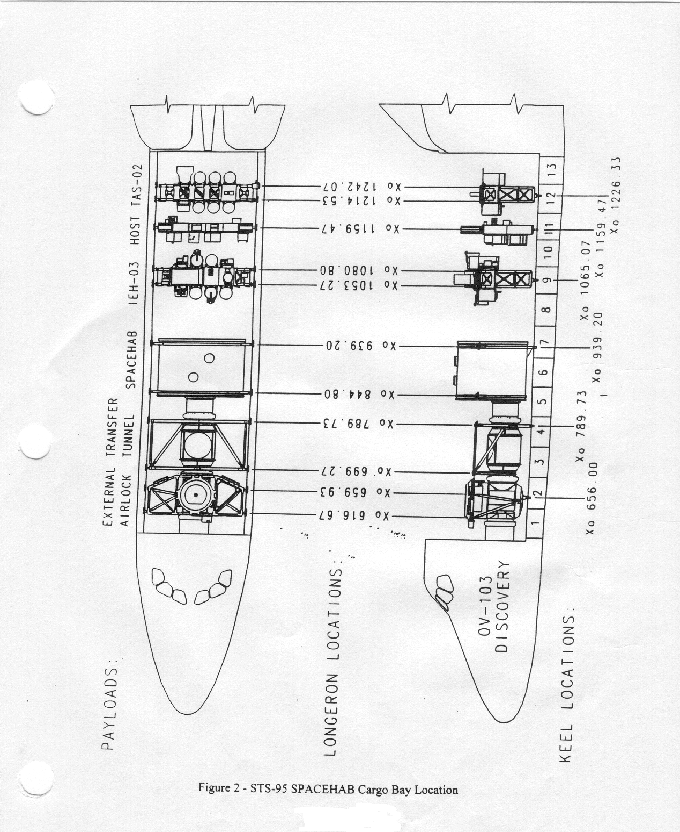
C-11
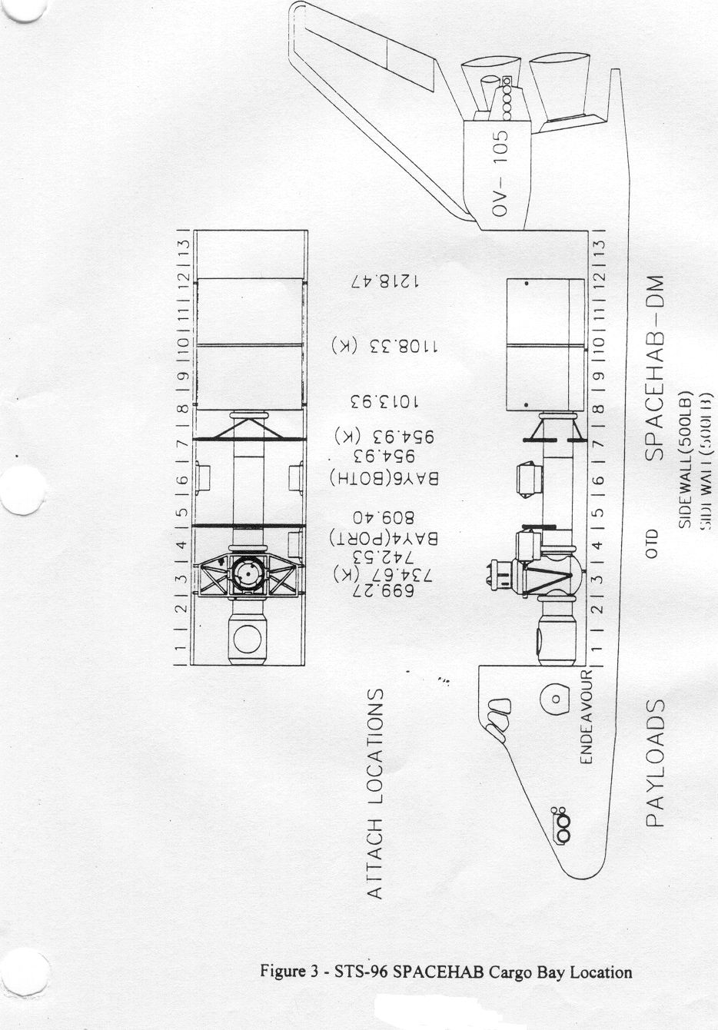
C-12
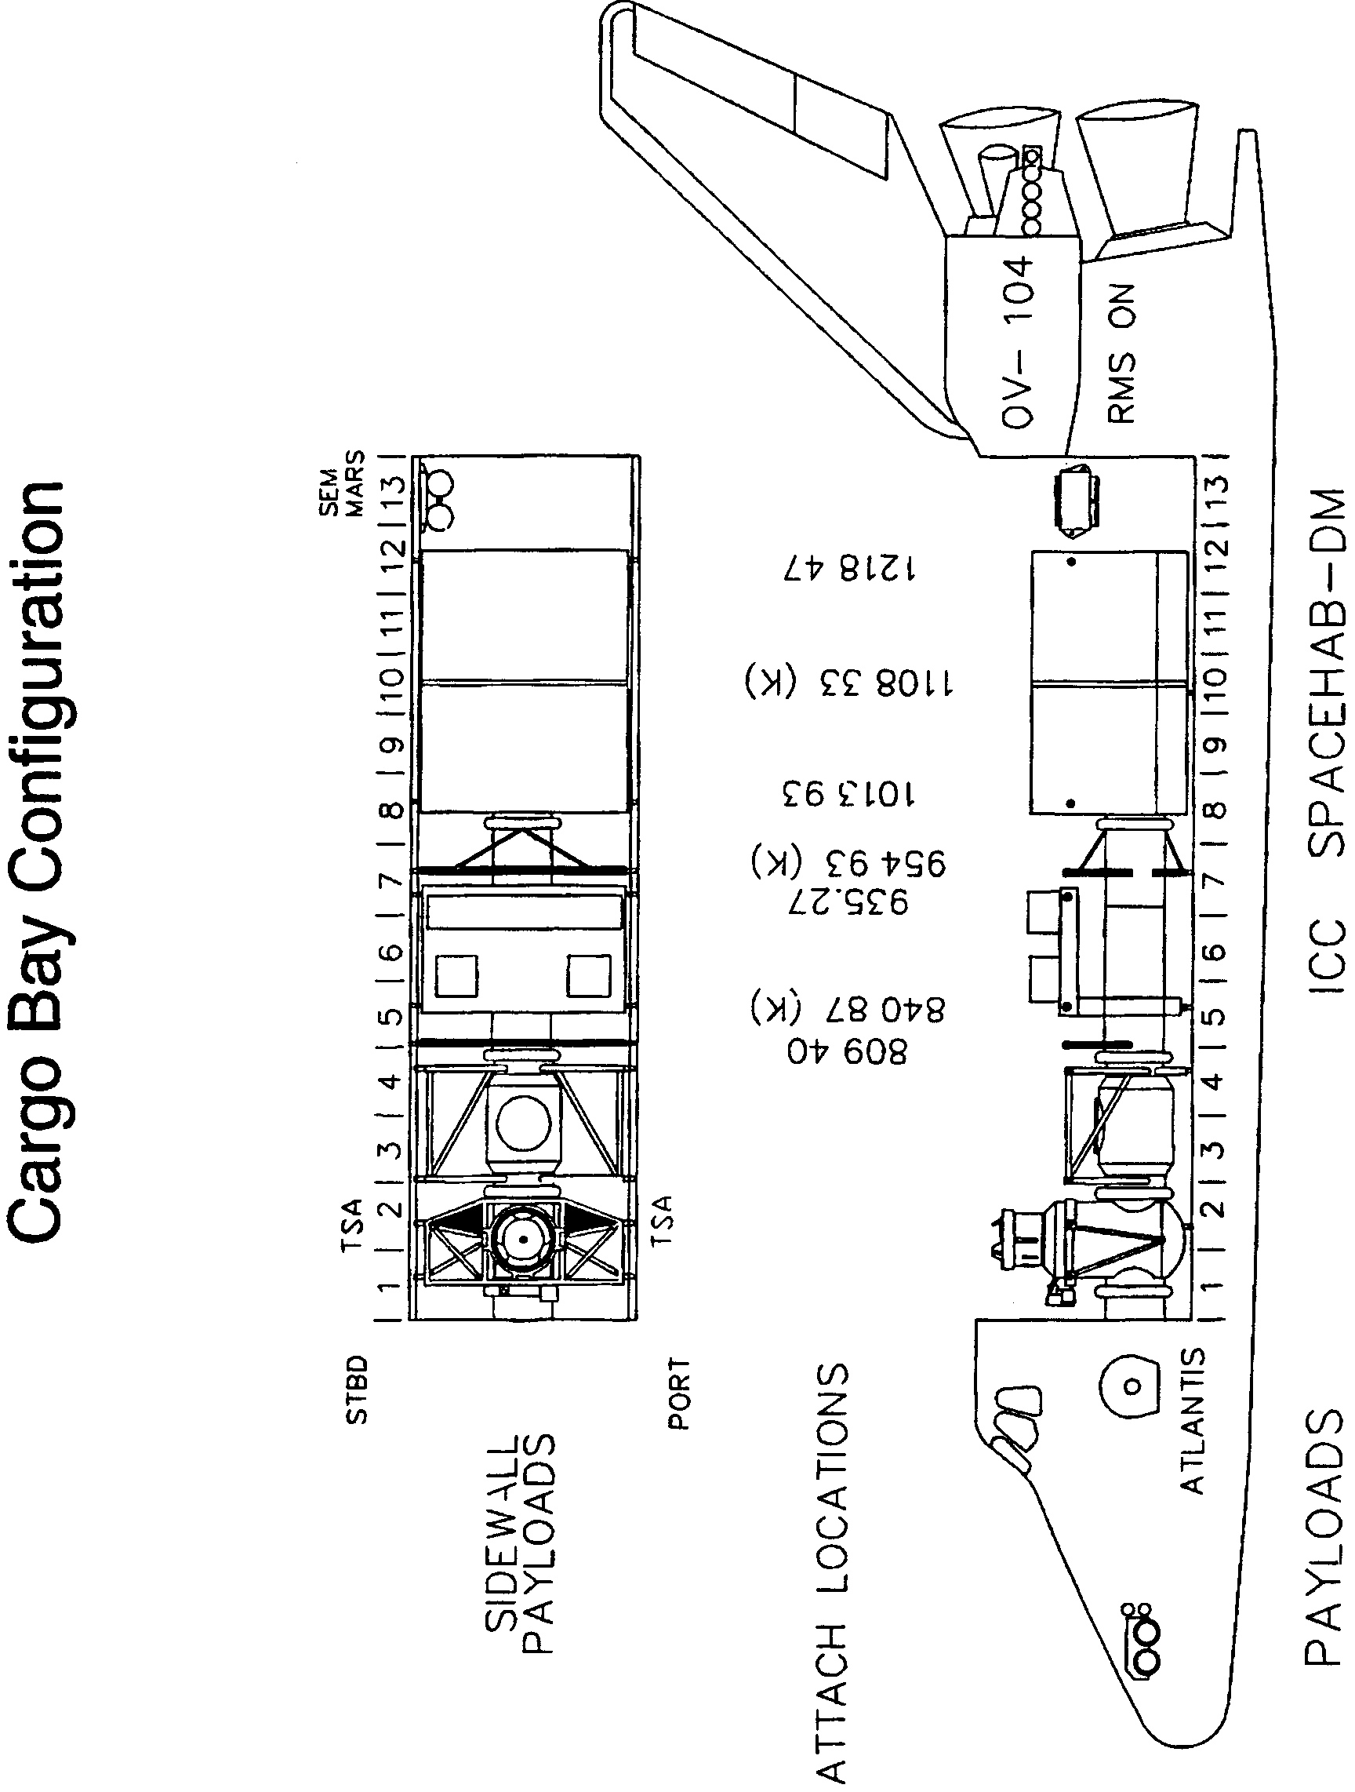
Figure 4 – STS-101 and STS-106 SPACEHAB Cargo Bay Location

C-12a
2.4 SUMMARY OF SPACEHAB INTEGRATED CARGO CARRIER RESOURCES

SPACEHAB ICC resources availability shall be a principal consideration in Contractor assessments of feasible flight manifests for passive payloads in an unpressurized environment and in the development of associated payload integration and crew training milestones. NASA will share ICC resources with the Contractor whenever possible on any SPACEHAB mission on which an ICC is manifested. The percentage of the ICC resources allocated to NASA and Contractor payloads shall be jointly determined on a mission-by-mission basis, and shall be based on the total payload resources provided by the SSP.
All ICC resources (mass, volume, power, energy, crew time, etc.) shall be assumed to be divided initially between NASA and the Contractor in proportion to ICC gross ascent payload mass, with the understanding that the unique resource requirements of the individual payloads will be taken into consideration in the assessment process to assemble a mission complement that effectively integrates as many of the highest priority payloads as possible without exceeding the total resources allocated by the SSP for the mission.

The Contractor shall be allowed to market to, and contract with, the international partners and the non-NASA sector for its portion of the ICC resources. In the event the Contractor is unable to market their apportioned share of resources, the Government shall not be liable for any portion of the Contractor’s share of fixed expenses such as flight hardware and facility depreciation, maintenance, mission integration costs, etc.

The following resources shall be considered as the ICC resources available to the Government on any SPACEHAB mission manifesting an ICC:

- External payload mounting area on the ICC (upper surface only on STS-96 and STS-101).

- SPACEHAB ICC gross ascent and descent payload mass allocated to the Government. Manifesting more or less gross payload mass on any mission, up to the limits of Orbiter ascent performance, center-of-gravity limits, or ICC structural capability, is not precluded.

- Payload late access capability (Payload(s) must be compatible with KSC and the Contractor’s vertical installation Ground Support Equipment (GSE) to use this capability).

- Standard interface hardware (generic payload mounting plates) to accommodate payloads to be flown on the SPACEHAB ICC.

- Payload-required ancillary equipment in current SPACEHAB inventories (standard wiring harnesses, connectors, fasteners, etc.)

The following table provides the NASA and Contractor ICC resource allocations, by mission, for the missions covered in this contract.

Mission | Config. | Mass  Capacity | NASA Allocation  %, (lbm), [kg] | Contractor Allocation  %, (lbm), [kg]
STS-96 | ICC | 6000 lbm | 100, (1800), [816] | 0
STS-101 | ICC | 6000 lbm | 100, (1800), [816] | 0
STS-105 | ICC | 6000 lbm | 100, (TBD), [TBD] | 0
STS-106 | ICC | 6000 lbm | 100, (1800), [816] | 0
STS-116 | ICC | 6000 lbm | 100, (6000), [2721] | 0
STS-118 | ICC | 6000 lbm | 100, (6000), [2721] | 0

C-13
When required by the payload complement defined for any mission the Contractor shall provide to NASA under Article H.8 of the contract SpaceHab Oceaneering Space Systems (SHOSS) protective enclosure(s) to be installed on the ICC for payload items not accommodated on separate payload-provided unique support structures. Each SHOSS enclosure shall be capable of accommodating up to 400 lbm [181 Kg] gross payload mass. Other special purpose hardware and services for payload support are available as non-standard services (see Article H.8 of the contract).

2.5 ORBITER MIDDECK RESOURCES

The objective of the manifesting process is for the Contractor to stow the payload gross weight required by the contract in locations that most logically meet the late access/early retrieval, or other, requirements of the payloads. To accomplish this the Contractor shall request from the SSP PIM, if required, a sufficient number of Orbiter Middeck Locker Volumes (MLV’s) to allow late stowage of payload items, installation of time-critical experiments or samples or, when dictated by module volume limitations, MLV’s to bring the payload complement gross mass to contractually required values.
In the case where unused module volume and mass carrying capability is available as a result of Orbiter middeck locker volume provided to the Contractor by the SSP for stowage of late access/early retrieval payloads, and there are passive SSP payload items requiring stowage, the Contractor shall make available, if required, module accommodations and standard interface hardware for stowage of these items.

For the STS-116 and –118 missions the Contractor shall integrate and deintegrate the ISS middeck ascent and descent payloads which are part of the overall mission ISS payload complement (approximately 2000 lbs gross mass) on each mission.

The Contractor shall integrate the assigned payloads requiring Orbiter middeck accommodations as part of the SPACEHAB payload complement using standard Space Shuttle Program processes, procedures and documentation as defined in NSTS 07700, Volume XIV, Space Shuttle System Payload Accommodations.

2.6 DESIGN REVIEWS AND PROGRAM STATUS

The Contractor is responsible for conducting reviews during the design and development process of a fully resourced RDM (under development), the ICC, and the 27.14 inch SPACEHAB Tunnel segment identified in Section 3.1 and manufactured under this contract. During the design review process the Government shall be provided an opportunity to participate as observers in the design reviews and submit Review Item Discrepancies (RID’s), if desired, pertaining to the Space Shuttle-to-SPACEHAB module, or Space Shuttle-to-ICC interfaces and operations. Government participation in the review process shall not unilaterally impose new requirements on the design. NASA and other agency participation in these reviews does not constitute approval of the design nor certification as to its reliability.

The Contractor shall submit monthly Progress Reports (DRL Line Item No. 1) to the Government for its use in maintaining visibility of contract performance, current flight hardware status, payload and mission integration status, technical accomplishments compared with planned activities, and areas of concern. Formal submittal shall follow review and discussion of the draft report’s contents at the monthly Program Status Review meeting.

Beginning in February, 1998 monthly Program Status Review meetings will be held between the Contractor and the Government at mutually agreeable locations. Topics for discussion shall include, but not be limited to, the material contained in the draft monthly Progress Report (DRL Line Item No. 1). The reviews will be jointly chaired by the COTR and the Spacehab, Inc. Program Manager with the SSP PIM for each mission in attendance, if available. Presentations from the Contractor will be made, and formal, in-scope action items assigned. Presentation material will be provided electronically or by facsimile prior to the meeting.
C-14
3.0 SPACEHAB MODULE PERFORMANCE REQUIREMENTS

3.1 MODULE CONFIGURATION

The dimensions, mass, volume and other accommodations of the SPACEHAB module described in this section shall be such that they are contained within the Orbiter cargo bay and connect to the Tunnel Adapter or External Airlock hatch opening. The structural/mechanical interface between the SPACEHAB module and the Space Shuttle Orbiter shall consist of four longeron trunnions and one keel trunnion that shall attach to SSP-provided longeron and keel attach fittings. The cargo bay configuration for STS-95 is shown in Figure 2. The cargo bay configuration for STS-96 is shown in Figure 3, and the configuration for STS-101 and STS-106 is shown in Figure 4. The cargo bay configuration for STS-107 is shown in Figure 5. The cargo bay configurations for STS-116 and STS-118 are shown in Figures 6 and 7, respectively.

The Contractor shall provide, beginning with the STS-95 mission, a tunnel segment 27.14 inches long which shall interface with a tunnel segment or flex section, and the SPACEHAB module forward bulkhead. The Contractor shall provide, beginning with the STS-107 mission, a tunnel segment 7.87 inches long with supporting tunnel struts that connect to the Shuttle Orbiter longerons. This segment shall interface with the Mir Tunnel Assembly and a flex section to locate the module keel trunnion at Orbiter X-station 884.13 inches.

To support installation of the LSM in Orbiter Vehicle (OV)-102 for the STS-118 mission the Contractor shall perform a Modal Survey Test and structural analysis of the proposed tunnel configuration required for a module keel trunnion location at Orbiter X-station 939.20 inches. Tunnel segments used shall be modified as needed for the installation, including modifications to internal air ducting and external Multi-Layer Insulation (MLI) blankets.

The complete structural/mechanical interface between the SPACEHAB SM, LSM, the LDM and the Orbiter shall be specified in ICD-A-21095, Shuttle Orbiter/SPACEHAB Cargo Element Interfaces, the SSP A-level Orbiter-to-SPACEHAB Interface Control Document (ICD). The complete structural/mechanical interface between the RDM and the Orbiter shall be specified in ICD-A-21426, Shuttle Orbiter/SPACEHAB RDM Cargo Element Interfaces.

NASA will utilize, either directly for a full complement of NASA-provided payloads, or in combination with the Contractor in a payload sharing arrangement, the full volumetric and/or mass capabilities of the SPACEHAB modules, to the extent allowable by center of gravity and ascent performance considerations.

The overall design of the single and double modules must minimize reduction in launch performance and complexity of physical integration into the Orbiter while maximizing manifesting flexibility and must be easily accessible from the Orbiter middeck when on orbit. Interior volume and external mounting area shall accommodate projected payload manifests. Foot restraints, handholds, air diffusers, and lighting shall be provided in appropriate locations in the module interior. A work station may be required to support specific payload requirements.

The SPACEHAB modules shall provide accommodations for items sized to fit standard Orbiter middeck lockers, and equipment designed to utilize standard middeck locker interfaces. Stowage of larger or irregularly shaped items through the use of non-standard interface hardware is not precluded. SOFT STOWAGE ® system bags, straps and mounting hardware for passive stowage items shall be used wherever possible as a weight-saving measure, however, mass capability shall be determined by mission specific loading.

C-15
The Contractor shall provide the unique hardware, services and facilities necessary to support integration of the following oversized items on the STS-101 mission: IRED Adapter Plate, IRED Top Squat Supports (Qty. 2), FGB Stowage Enclosures (Qty. 6), PMA 3 Duct Extension Kit, Cycle Ergometer, IVA Seal Kit ,1 Rigid Air Duct, and TVIS Treadmill Shell.

To return excess low density packing material from the ISS on Logistics missions the Contractor shall provide a stowage bag arrangement that may be stowed for ascent and deployed for descent.

To support flight crew operations aboard the ISS, the contractor shall provide four trash containers, Part No. 9062250-1. Two containers shall be flight items certified for use on ISS, and two shall be Class III training hardware. In addition, 42 replaceable trash container liners, Part No. 9062251-1, shall be provided. Forty shall be flight items certified for use on ISS, and two shall be Class III training hardware. Delivery of all items shall support the launch of STS-101. Accommodations for SPACEHAB single or double racks shall be provided in the single module and in both segments of the double module. Rack mounting capabilities shall accommodate 19-inch wide experiment front panels conforming to EIA Standard RS-310-C. SPACEHAB racks, both single and double, shall be capable of being outfitted as SOFT STOWAGE ® racks, capable of accommodating either Contractor-provided SOFT STOWAGE ® bags or NASA-provided Collapsible Transfer Bags (CTB’s).

The Contractor shall provide the unique rack integration hardware, facilities, and services necessary to support integration of the Bearing Motor Roll Ring Module (BMRRM) and DC/DC Converter Unit -–External (DDCU-E) payloads into a SPACEHAB double rack for the STS-96 mission. In addition, on STS-96 the Contractor shall provide the unique hardware, facilities, and services necessary to support the integration of the Sequential Shunt Unit (SSU) payload in the aft module subfloor.

To support the off-site integration and testing of the Combustion Module-2 (CM-2) payload on STS-107, the Contractor shall lease to the Government for the use of the NASA-Glenn Research Center (GRC), for a period of approximately two and one-half years, from March 1, 1999, until 10 months after the return of STS-107 (R+10 months), one single and one double SPACEHAB rack, a Rack Distribution Unit (RDU), rack suction cooling trees, and rack ground handling equipment.

The Contractor shall pay shipping charges from the SPACEHAB Payload Processing Facility (SPPF) to GRC for the initial shipment of the deintegrated racks and ground handling equipment, and for the post-flight shipment of the integrated racks from the SPPF to GRC. GRC shall pay shipping charges from their facility to the SPPF for the integrated racks pre-flight, and for the final return of the deintegrated racks and ground handling equipment from GRC to the SPPF. Shipment of integrated racks shall be by air-cushioned truck transportation with temperature and humidity control.

During the period of the lease, the Contractor shall provide sustaining engineering support of the hardware leased. The Government shall have the option to extend the duration of the lease at any time during the lease period as required to support the flight of the CM-2 payload on STS-107. There will be no additional charge to the government for this extension. Should the CM payload fly on subsequent SPACEHAB missions, there will be no additional charge for use of this rack hardware within the standard 15 month SPACEHAB integration template.

During the lease period, the Contractor shall provide the following non-standard services to support rack/payload testing and integration activities at GRC:

- Support modal survey and random vibration testing at GRC including test set-up and performance troubleshooting and adaptive hardware model verification.
- Review GRC CM-2 drawings, plans, procedures and requirements, as related to rack installation and removal, testing and integration. Develop a constraints document for the Rack Distribution Unit (RDU).
- Support rack assembly and integration at GRC, including field engineering and troubleshooting.
C-16
4. Support preliminary data system testing (Experiment Interface Unit and Ethernet) at the SPPF.

5. Provide support in advance of the normal integration schedule template for Core Interface Control Document (ICD) development, development and maintenance of project schedules, and overall coordination of CM-2 activities.
6. Provide support in advance of the normal integration schedule template for mission engineering consultation, assessment of experiment design and verification requirements, ICD Appendix B development, data review and coordination, ICD Core and Appendix A review, and Technical Interchange Meeting (TIM) support.

The SPACEHAB modules shall have the capability to accommodate one International Standard Payload Rack (ISPR) on any mission through the use of a Contractor-provided ISS to SPACEHAB Adapter (ISA). Because of the specialized hardware required, the ISA/ISPR can only be installed in the Single Module, LSM, or the forward segment of the LDM, in the Standard Aft rack position. Other payload accommodations required include Z-axis viewing through one or more Government-provided view ports, vacuum vent capability, power, cooling, video and data management, late access/early retrieval of payloads from the modules, and ascent and descent power.

SPACEHAB payload translation aids and stowage systems shall be designed such that they do not preclude transfer of payloads to/from the module on the launch pad, or on-orbit, through the existing Space Shuttle middeck and airlock, Tunnel Adapter and External Airlock hatch openings.

Provisions shall be included in flight and ground crew training, procedures, module outfitting, and systems stowage to perform scheduled and unscheduled inflight maintenance of the SPACEHAB modules.

The Contractor shall provide and install structural closeout panels in a SPACEHAB double rack to support the integration of the Volatile Removal Assembly (VRA) experiment on the STS-96 mission in the configuration previously flown on STS-89.

The Contractor shall provide all unique flight and ground test power, data, and video cables for the NASA-sponsored experiments on the STS-107 mission.

The contractor shall provide all hardware, facilities and services necessary to integrate the Vapor Compression Distillation (VCD) Experiment into a SPACEHAB rack for STS-107.

For the STS-101 mission, the Contractor shall provide the unique hardware, facilities, and services necessary to integrate an Orbital Replacement Unit (ORU) Fan Assembly into the SPACEHAB module on the launch pad. This effort includes demanifesting or relocating, as necessary, payloads already stowed for flight.

3.2 ENVIRONMENTAL CONTROL

The SPACEHAB modules shall preserve a crew habitable "shirtsleeve environment" when integrated with the Orbiter. Air temperature, surface temperatures, carbon dioxide concentration, air circulation, moisture condensation, contamination and humidity control shall be maintained to assure a safe environment for a minimum of two crew members working simultaneously and continuously, or for three to four crew members working for shorter periods. An environment comparable to that in the Orbiter middeck shall be maintained.

C-17
3.2.1 Heat Rejection

The SPACEHAB modules, when integrated into the Orbiter, shall reject heat from subsystems and payloads using module air flow or utilizing a forced air and/or liquid cooling system. The total SPACEHAB Single Module (STS-95), LSM (STS-116 and STS-118) and limited resource LDM (STS-96 and subsequent) cargo element may require up to 6.0 kilowatts of active cooling on orbit and 1,500 watts during prelaunch, ascent, descent and post-landing phases of flight. The fully resourced RDM (STS-107 and subsequent) cargo element may require up to 8.5 kilowatts of active cooling on orbit and 1.52 kilowatts during prelaunch, ascent, descent and post-landing phases of flight. The RDM liquid cooling loop shall be designed to provide cold (below 65 deg. F) water-cooling to rack mounted payloads at all rack locations. Heat rejection shall be compatible with Shuttle Orbiter/Cargo Standard Interfaces, ICD-2-19001, and defined in ICD-A-21095 (STS-95/-96/-101/-106/-116/-118) and ICD-A-21426 (STS-107).

The Contractor shall perform mission-unique thermal analyses as a part of the SPACEHAB Mission Performance Analyses (DRL Line Item No. 4) which verify that the SPACEHAB module and its manifested payloads can operate during routine mission situations at a cabin temperature between 65 deg. F and 80 deg. F, consistent with the cooling requirements of the payloads.

3.2.2 External Thermal Requirements

The SPACEHAB modules shall be compatible with the attitude-hold capability of the Orbiter, which is defined in Section 6.1.1.2 of ICD-2-19001, and shall not require any on-orbit thermal attitude constraints in a fully operative mode. In the event of degraded performance of SPACEHAB subsystems, the Contractor shall not rely on Orbiter attitude control to prevent module external water line freezing.

3.2.3 Vacuum Venting

3.2.3.1 Module Venting

For safety, the capability to vent the module internal atmosphere to space shall be provided and shall be capable of activation by the crew from the safe haven of the Orbiter.

3.2.3.2 Payload Venting

The SPACEHAB modules shall provide a capability to allow multiple payloads on any mission to be exposed to a controlled vacuum environment. This will be an on-orbit operation performed by the crew and shall not jeopardize the safety of the flight crew, degrade or endanger the module, its systems, or other payloads on the mission.

3.3 ELECTRICAL POWER

The SPACEHAB Single Module (STS-95), LSM (STS-116 and STS-118) and LDM (STS-96 and subsequent), when integrated into the Orbiter, shall be capable of accommodating two (2) Orbiter power feeds to supply up to 3.5 kilowatts of continuous and 6 kilowatts peak DC power during on-orbit (payload bay doors open) operations. Accommodations on both power feeds for switching of power to the module shall be provided by the Contractor. In addition, the SPACEHAB modules identified above shall accommodate 690 volt-amps (VA) continuous and 1,000 VA peak AC power during on-orbit (payload bay doors open) operations from auxiliary feeds. For ascent and descent, the module shall accommodate 1.3 kilowatts of DC power only. Refer to ICD-A-21095 for details. The module shall provide these standard services to numerous interface locations as needed to meet the payload requirements defined in each mission-specific MRAD (DRL Line Item No. 14). All payload locations shall be accessible to these accommodations and easily integrated.

C-18

The SPACEHAB fully resourced RDM (STS-107 and subsequent), when integrated into the Orbiter, shall be capable of accommodating four (4) Orbiter power feeds to supply up to 7.0 kilowatts of continuous and 12.0 kilowatts peak DC power during on-orbit (payload bay doors open) operations. Accommodations on power feeds for switching of power to the module shall be provided by the Contractor. In addition, the SPACEHAB RDM shall be capable of accommodating 1380 volt-amps (VA) continuous and 2,000 VA peak AC power during on-orbit (payload bay doors open) operations from auxiliary feeds. For ascent and descent, the module shall accommodate 2.6 kilowatts of DC power only. Refer to ICD-A-21426 for details. The module shall provide these standard services to numerous interface locations as needed to meet the payload requirements defined in each mission-specific MRAD (DRL Line Item No. 14). All payload locations shall be accessible to these accommodations and easily integrated.

The power system design for safety critical systems and subsystems shall comply with the applicable redundant electrical power and failure requirements of the Safety Policy and Requirements for Payloads using the Space Transportation System, NSTS 1700.7B. Specifically, a Main Power Kill command shall not remove power permanently from safety-critical module AC powered equipment (ARS and Cabin fans and dual water circulation pumps). If fans and/or water pumps are powered by the SPACEHAB inverters when the power kill function is initiated, the capability shall exist to switch the power source for fans and water pumps to Orbiter AC power from a location outside the module.

3.4 COMMAND AND DATA MANAGEMENT SYSTEMS

All SPACEHAB cargo elements shall be compatible with the existing Orbiter command and telemetry systems and utilize those services currently provided as standard payload accommodations. The SPACEHAB modules shall provide a Command and Data Management system that is capable of performing, as a minimum, the following functions:

3.4.1 Orbiter-To-Module Services

3.4.1.1 Monitoring and Control

Provide the capability within the Orbiter crew compartment for sufficient monitoring and control of the module subsystems to perform time critical and safety critical operations without requiring access to the module itself. Provide capability to monitor module status during all phases of flight and ground operations when the module is powered. This capability requires that module systems be adequately instrumented to allow monitoring not only of safety critical functions such as fire detection and suppression, and cabin pressure, but also of mission success-related functions which control routine module-to-payload interfaces and services such as power to payload lockers and racks.

SPACEHAB module systems health parameters capable of being monitored from the Orbiter aft flight deck must also be capable of being monitored from within the module. A Government-furnished Payload and
General Support Computer (PGSC) shall be used to provide this capability. The software developed by the Contractor for subsystems monitoring and control shall be compatible with a 760XD based subsystem PGSC.

C-19

3.4.1.2 Command and Data

For any module configuration, provide the capability for the module systems and payload data to be included in the Orbiter downlink telemetry and if required, to the Orbiter Multifunction Cathode ray tube Display System (MCDS). Uplink command capability to SPACEHAB module systems and payloads shall be provided.

3.4.1.3 Flight Crew Communications

Provide the capability to interface with the Orbiter Air-to-Ground and crew compartment intercom systems.

3.4.1.4 Closed Circuit Television (CCTV)

Provide the capability to interface with the Orbiter CCTV system for remote television capability in any module configuration. Services shall also be provided by the module to utilize Orbiter camera systems (camcorders).

When dictated by payload requirements, video switching capability shall be provided in any SPACEHAB module configuration to allow selection of one output to the Orbiter CCTV system from multiple payload or module cameras. All module configurations shall be capable of providing digital video downlink capability as a standard SPACEHAB system service, if required by one or more experiments.

If the SSP defines a requirement on any mission to view the payload bay area behind the SPACEHAB module the Contractor shall install Orbiter CCTV cameras external to the module and located on the aft bulkhead using GFE installation hardware and cameras.

3.4.1.5 Caution and Warning ( C&W)

All module configurations shall be compatible with the Orbiter C&W system for safety critical status.

3.4.2 Module-to-Payload Services

3.4.2.1 Monitoring and Control

Provide control and monitoring capability for payloads through the use of standard Space Shuttle Orbiter laptop computers, e.g. the PGSC, in order to standardize the crew-to-payloads interface.

C-20

3.4.2.2 Command and Data

For any module configuration, to the extent that payload data is required by the JSC POCC, and is within the standard SPACEHAB data system capabilities, provide services for inclusion of payload data in the SPACEHAB cargo element data stream to the Orbiter downlink telemetry systems. Uplink commanding between the JSC POCC and SPACEHAB payloads shall be provided when required.

3.4.2.3 Onboard Recording

Provide an interface to the Orbiter Payload Recorder for onboard recording of payload data.

3.4.2.4 Timing Signals

Provide the appropriate timing signal services for payload use. This shall include, but not be limited to, Orbiter Mission Elapsed Time (MET) and Greenwich Mean Time (GMT) signals.

3.5 ELECTROMAGNETIC INTERFERENCE/COMPATIBILITY (EMI/EMC)

The SPACEHAB module cargo element shall be compatible with the EMI/EMC requirements as specified in ICD-2-19001. Additional requirements are as follows:

a. The SPACEHAB modules shall be capable of tolerating Ku-Band external radiation with no operational constraints on the Space Shuttle and without sustaining performance loss or degradation.

b. The Contractor shall be responsible for insuring that the payload complement meets all specifications for EMI/EMC between the payload and the Orbiter, the payload and the module and between payloads within the module and shall so certify. This certification is required by NASA as part of the overall SPACEHAB certification for flight.

3.6 EXTRAVEHICULAR ACTIVITY (EVA) COMPATIBILITY

All SPACEHAB cargo elements shall be compatible with Space Shuttle EVA design requirements contained in NSTS 07700, Volume XIV, Appendix 7, System Description and Design Data - Extravehicular Activities including the interim sharp edge policy for payloads contained in NASA-JSC letter MT2-96-170 dated November 20, 1996, with enclosure letter XA-96-177. The modules, with any external payloads installed, shall not preclude EVA access to the Orbiter payload bay door contingency work areas with the payload bay doors closed. The Contractor shall treat as out-of-scope any payload requirement violating this restriction and contact the COTR before performing an accommodations analysis.

The module shall be compatible with existing EVA capabilities and EVA planning. The existing ISS Tunnel Adapter or External Airlock will be used to provide an egress/ingress location for EVA.

C-20a

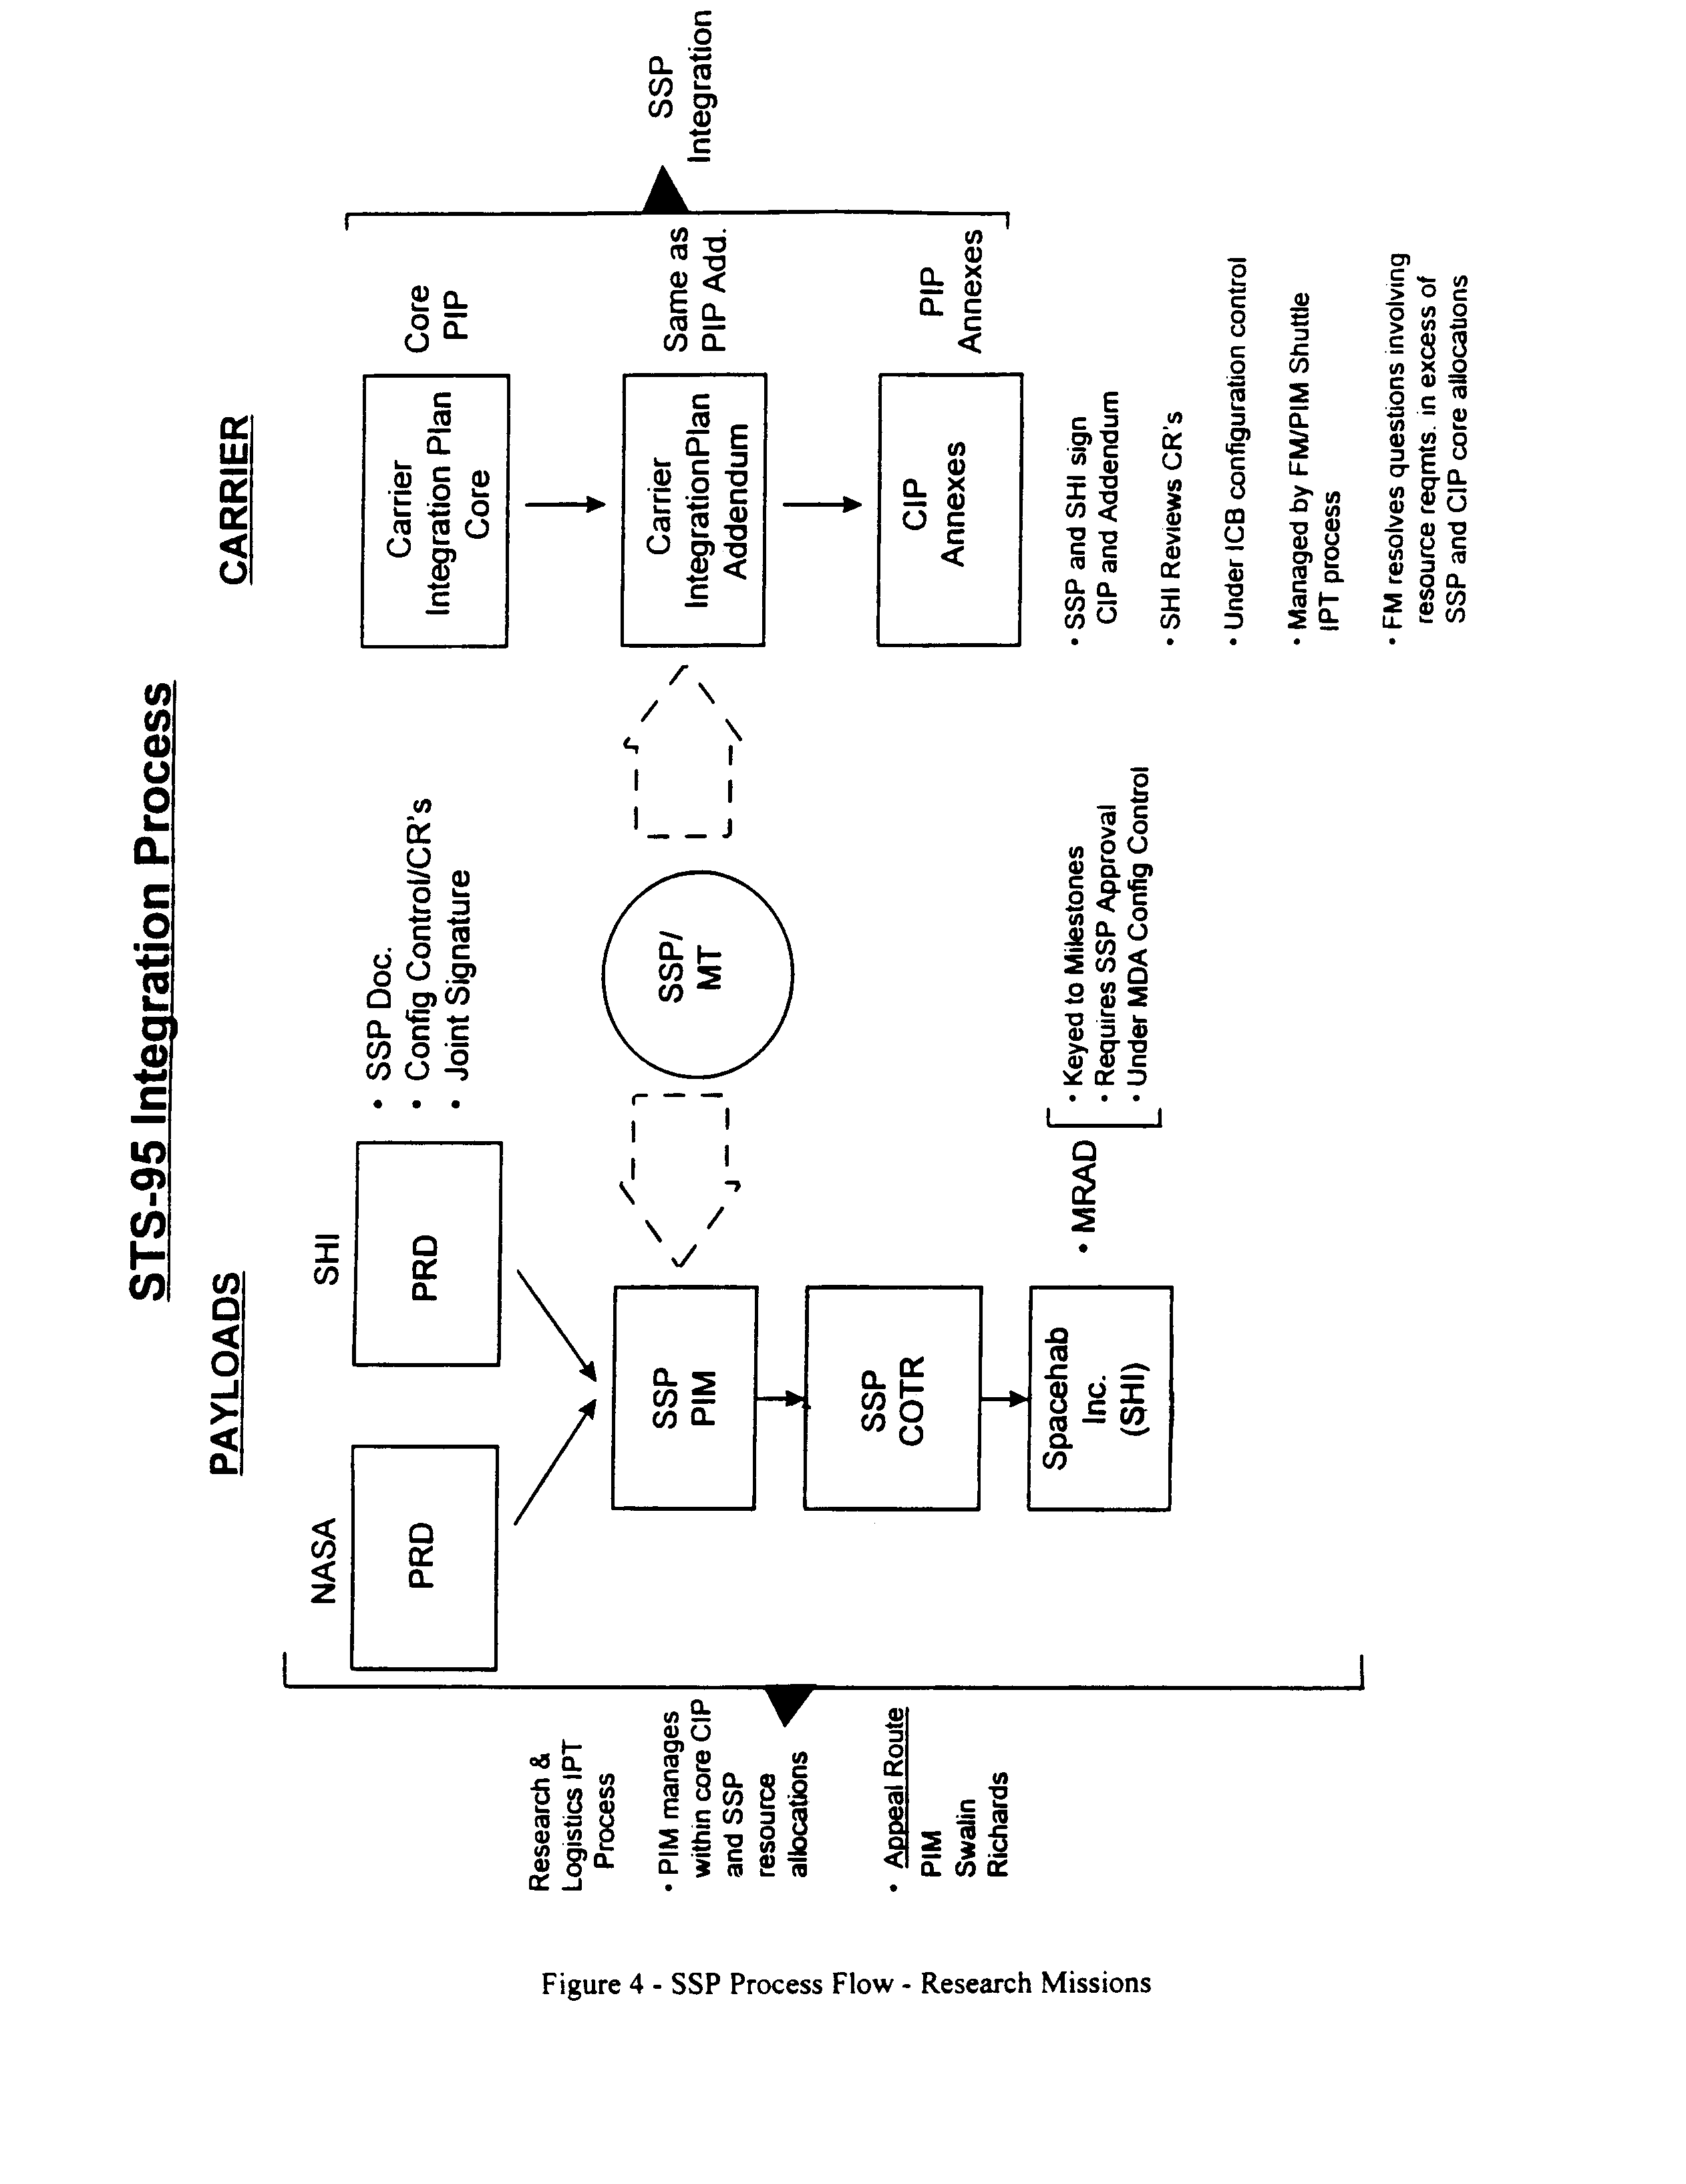

C-21

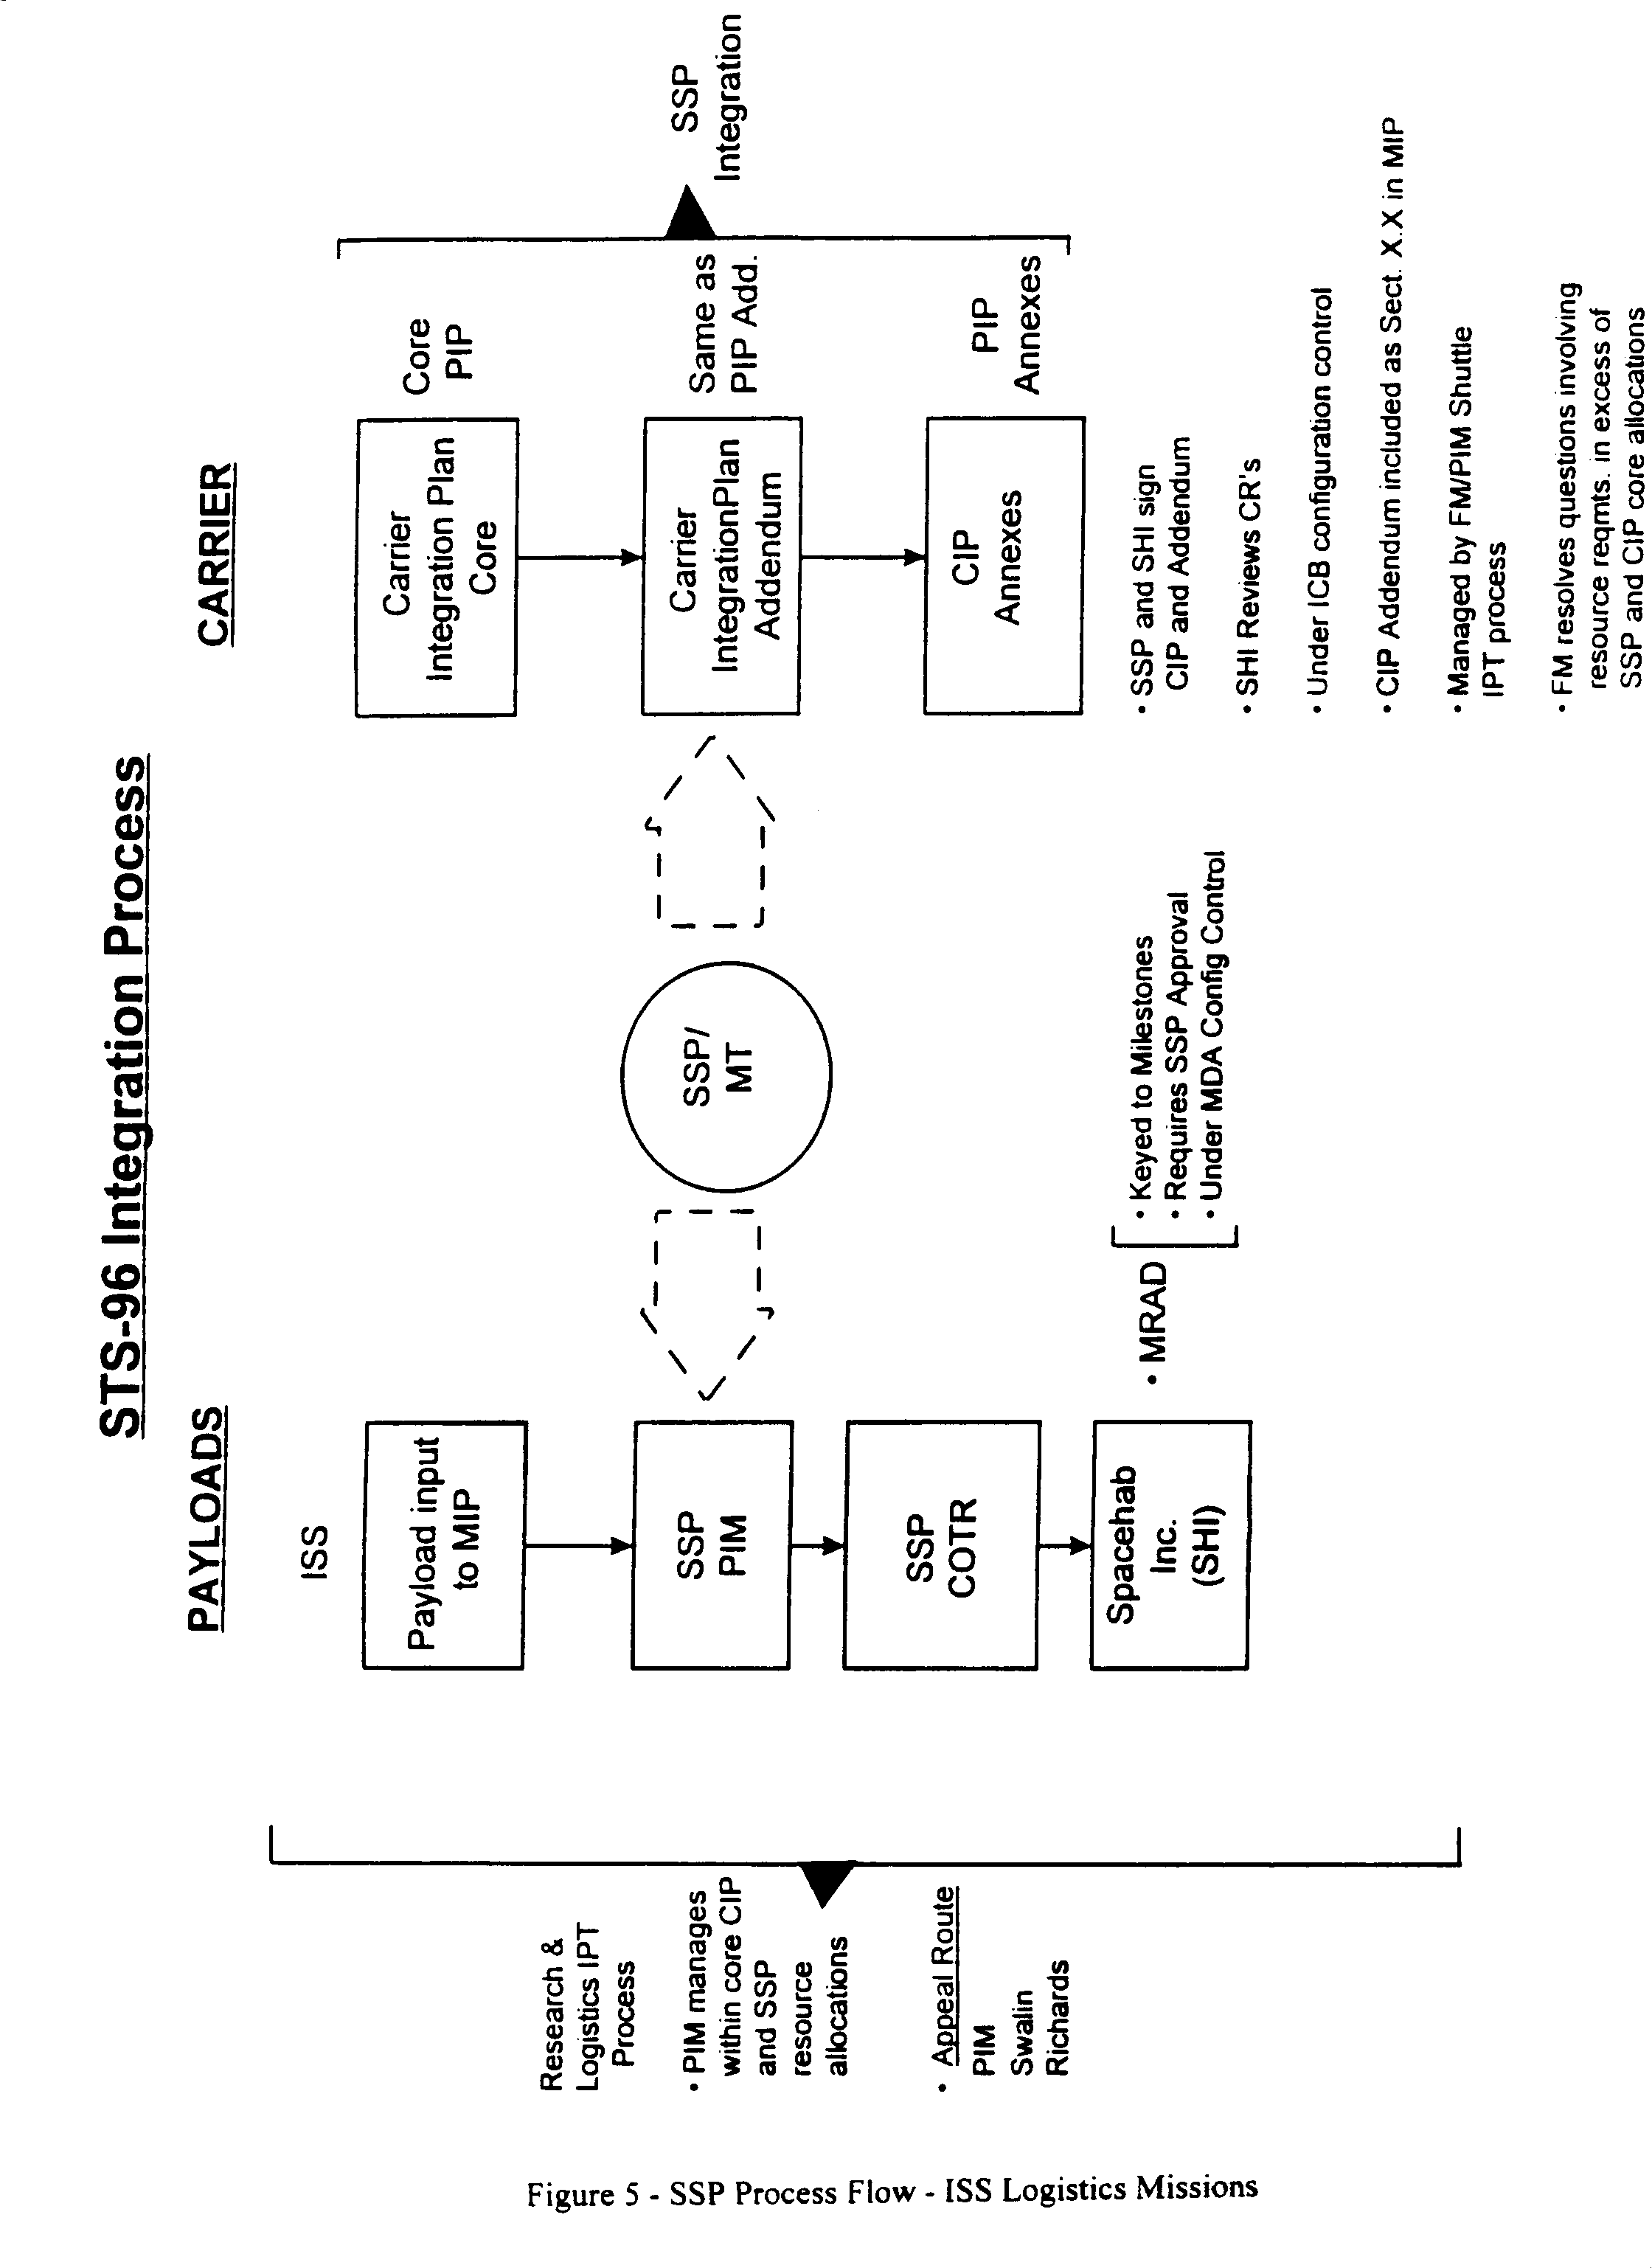
C-22

4.0 SPACEHAB ICC PERFORMANCE REQUIREMENTS

4.1 ICC CONFIGURATION

The dimensions, mass, volume and other accommodations of the SPACEHAB ICC described in this section shall be such that they are contained within the Orbiter cargo bay and accommodate installation in the cargo bay either ahead of or behind the SPACEHAB module. The structural/mechanical interface between the ICC and the Space Shuttle Orbiter shall consist of four longeron trunnions and one keel trunnion that shall attach to SPP-provided longeron and keel attach fittings. The cargo bay configuration
for STS-96, including the ICC, is shown in Figure 3. The ICC configuration in the cargo bay for STS-101 and STS-106 is shown in Figure 4. The ICC configuration in the cargo bay for STS-116 and STS-118 is shown in Figures 6 and 7.

Beginning with the STS-116 mission the Contractor shall provide an ICC Keel Yoke Assembly (KYA) keel trunnion pin compatible with an SSP-provided Orbiter passive keel latch. This trunnion pin shall have a mounting interface common with the active latch keel trunnion pin, allowing either to be used on any KYA. The complete structural/mechanical interface between the SPACEHAB ICC and the Orbiter shall be specified in ICD-A-21448, Shuttle Orbiter/ ICC Cargo Element Interfaces, the SSP A-level Orbiter-to-SPACEHAB Interface Control Document (ICD).

NASA will utilize, either directly for a full complement of NASA-provided payloads, or in combination with the Contractor in a payload sharing arrangement, the full volumetric and/or mass capabilities of the SPACEHAB ICC, to the extent dictated by mission manifesting requirements and allowable by center of gravity and ascent performance considerations.

The overall design of the ICC shall emphasize payload manifesting flexibility and simplicity of payload installation while minimizing reduction in launch performance. The ICC and its GSE shall support either vertical or horizontal installation of the ICC in the Orbiter. The payload-to-ICC attachment system shall be designed such that it does not preclude installation of late access compatible payloads on the top surface of the ICC on the launch pad.

The Contractor shall provide the unique integration hardware, facilities and services necessary to integrate the Pump Flow Control System (PFCS) payload and the Flight Releasable Attachment Mechanism (FRAM) - mounted Early Ammonia Thermal Control Pump Module payload on an ICC for delivery to ISS on STS-116, and the Early Ammonia Servicer payload for return on STS-118.

Additionally, the Contractor shall provide two SHOSS enclosures for STS-116. The Contractor shall modify one of the SHOSS enclosures for On-orbit Replacement Unit (ORU) and FRAM compatibility, and to be deployed from the ICC and attached to the ISS on-orbit. Return of the SHOSS enclosure left on ISS after STS-116 may occur up to 5 years after deployment.

4.2 ICC THERMAL REQUIREMENTS

The SPACEHAB ICC, including the SHOSS enclosure (if manifested), shall be compatible with the attitude-hold capability of the Orbiter which is defined in Section 6.1.1.2 of ICD-2-19001 and shall not require any on-orbit thermal attitude constraints in a fully operative mode. In the event of degraded performance of payload thermal conditioning systems (if installed as a non-standard service), the Contractor shall not rely on Orbiter attitude control to assure payload survivability.

4.3 ELECTRICAL POWER

The design of the generic ICC provides no standard accommodations for electrical power transfer from the Orbiter. For the STS-116 and STS-118 missions the Contractor shall provide the unique hardware, facilities and services to manufacture and install a Launch On Need (LON) electrical power cable on the Unpressurized Cargo Pallet (UCP). The power cable shall be of sufficient length to allow routing to any standard payload location on the upper or lower surface of the UCP. Electrical connectors for connection to the Orbiter power cable and the LON payload(s) on the ICC shall be provided as GFE on loan to the Contractor.

C-23
4.4 ELECTROMAGNETIC INTERFERENCE/COMPATIBILITY (EMI/EMC)

The SPACEHAB ICC cargo element, including the SHOSS enclosure (if manifested), and its payloads, shall be compatible with the EMI/EMC requirements as specified in ICD-2-19001 and capable of tolerating Ku-Band external radiation with no operational constraints on the Space Shuttle and without sustaining performance loss or degradation.

4.5 EXTRAVEHICULAR ACTIVITY (EVA) COMPATIBILITY

The SPACEHAB ICC and its payloads, including the SHOSS enclosure (if manifested), shall be compatible with Space Shuttle EVA design requirements contained in NSTS 07700, Volume XIV, Appendix 7, System Description and Design Data – Extravehicular Activities including the interim sharp edge policy for payloads contained in NASA-JSC letter MT2-96-170 dated November 20, 1996, with enclosure letter XA-96-177. The ICC, with any external payloads installed, shall not preclude EVA access to the Orbiter payload bay door contingency work areas with the payload bay doors closed. The Contractor shall treat as out-of-scope any payload requirement violating this restriction and contact the COTR before performing an accommodations analysis.

The ICC shall be compatible with existing EVA capabilities and EVA planning. The existing ISS Tunnel Adapter or External Airlock will be used to provide an egress/ingress location for EVA.

5.0 CONTRACTOR INTEGRATION AND OPERATIONS RESPONSIBILITIES

The Contractor shall put in place and support a two-tier integration and operations process for these missions. The Contractor shall be responsible under this contract at the payload level (Level III) for integration of the NASA-provided payload complement, and at the cargo element, or carrier level (Level II) for mission integration of the module, ICC (if manifested), and its complete payload complement, NASA-provided as well as Contractor-provided.

The Contractor’s principal day-to-day Level II and III interface with the Government for each mission is the SSP PIM. The PIM collects payload requirements, defines and manages SSP mission resources within in the confines of a Carrier Integration Plan (CIP), and oversees the development and maintenance by the Contractor of an integrated payload complement. The PIM chairs an SSP IPT and other meetings as required to assure the technically complete and timely integration of the payloads and the cargo element.

Figure 8 is a process flow chart for Research-class missions, and Figure 9 is a flow chart for ISS Logistics-class missions showing how payload requirements are collected and combined, from the payload to the mission level, and the documentation and processes used to accomplish a coordinated and controlled flow of requirements into the SSP. Also shown is the relationship of the payload process with the SSP carrier, or cargo element, integration process.

5.1 PAYLOAD (LEVEL III) INTEGRATION

5.1.1 Payload Complement Definition

Beginning at approximately 15 months prior to launch the Government, through the COTR, shall identify to the Contractor, in the form of the ISS MIP or PRD’s for NASA-sponsored or SPACEHAB Inc.-sponsored payloads, the prioritized list of candidate payloads to be accommodated on each mission. The PRD’s and PRD changes are jointly signed by the SSP PIM and the NASA or SPACEHAB Inc. Payload Manager. The ISS MIP is jointly signed by the SSP Flight Manager and the ISS Deputy Manager for Operations. MIP changes are jointly signed by the SSP Flight Manager and the ISS Launch Package Manager (LPM).

C-24

Both the PRD and the MIP are under SSP configuration control. Periodic updates to the payload complement through revisions to the PRD’s and MIP can be expected from the COTR as the mission integration process progresses.

For the STS-107 mission, the Contractor shall provide to NASA for its use the unsold portion of the commercial mass (not less than 613 lbs.), together with such unused resources (power, energy, crew time, etc.) as exist after integration of the commercial payload complement. With the exception of the additional 3.5 hours of crew time provided to the ERISTO commercial payload from the NASA allocation, the SPACEHAB-sponsored payloads shall not use more than 18% of the resource allocation. To preserve the 82%/18% resource allocation ratio in Section 2.3, NASA shall select a group of payloads weighing approximately 555 lbs. for inclusion in NSTS 21464, the PRD for SPACEHAB Commercial Payloads on STS-107. The NASA payloads in this group shall have commercial payload priority in the PRD.

For the STS-116 and –118 missions the Contractor shall assess ISS Manifest Requests (MR’s) provided by the ISS LPM, and coordinated with the SSP PIM, on an individual basis for feasibility and compatibility with the Orbiter middeck, LSM and ICC/SHOSS resources available on the designated mission. The results of the MR assessments shall be presented by the Contractor to the SSP PIM and ISS LPM and used by the LPM to make decisions regarding the mission payload complement to be formally submitted and evaluated in MIP Change Requests (CR’s). The Contractor, in performing integrated payload and cargo element compatibility analyses supporting MIP manifest CR’s, may use the data collected originally to perform the MR assessments.

5.1.2 Payload Priorites

The mission-unique NASA Flight Requirements Document (FRD) establishes the priority for the assignment of Shuttle Orbiter resources to the payloads on any mission with shared commercial/NASA payloads.

C-25

5.1.3 Payload Analytical Integration

The Contractor shall perform the following tasks for each NASA-provided payload, in accordance with the processes defined in the MIOMP (DRL Line Item No. 9):

- Develop a core SPACEHAB-to-Payload Interface Control Agreement (ICA) (DRL Line Item No. 6). Complex, active payloads shall utilize an Interface Control Document (ICD) with ICD Appendix A (Ground Operations Interface Requirements); ICD Appendix B (Safety/Verification Requirements); and ICD Appendix C (Flight Operations Interface Requirements), as required. Less complex, passive payloads shall use Stowage Interface Agreements (SIA’s) or Payload Transfer Agreements (PTA’s), as appropriate for the requirements of the payload. ICA’s and revisions are signed by the Contractor and the organization responsible for payload development and delivery, with concurrence by NASA, if desired.

- Prepare payload Safety Analyses and Hazard Reports (DRL Line Item No. 7). These are submitted to the NASA Payload Safety Review Panel as required by the multi-phased safety review process.

- Develop payload stowage requirements. For ISS Logistics missions this includes developing requirements, processes and procedures for moving each ascent payload from its stowed location in the SPACEHAB module or Orbiter middeck (if applicable) to the module/transfer tunnel interface or transfer staging area in the Orbiter middeck. Descent payloads assigned to the Contractor shall reverse the process, moving from the module/transfer tunnel interface or middeck transfer staging area to the module or middeck stowed location. For the ICC (if manifested) this includes developing the requirements, processes and procedures for releasing each payload from the ICC or SHOSS enclosure retention mechanism and reinstalling it (if required).

- Perform analyses of all payload test/analytical data as it pertains to the physical (structural) and environmental (thermal, acoustics, EMI/EMC) interfaces with the SPACEHAB Module or ICC (if manifested).

- Validate payload-provided safety and interface verification products.

To assist in Government and Contractor assessments of the mission feasibility of SPACEHAB payloads, the Contractor shall maintain and provide to the Government a generic Payload Interface Definition Document (IDD) (DRL Line Item No. 15) which shall define all payload to SPACEHAB module or ICC interfaces.

C-26

In order for the Government to maintain cognizance over the individual experiments, the Contractor shall develop and maintain payload specific Interface Control Agreements (ICA’s) (DRL Line Item No. 6). The payload specific ICA’s shall be organized such that they address, item by item, the interface requirements set forth in the IDD.

The Contractor shall perform a Design Coupled Loads Analysis (DCLA) for the STS-107 Orbiter payload bay configuration at the RDM Orbiter x-station keel location of Xo 895.93 inches, using appropriate Orbiter mathematical structural models and forcing functions. The contractor shall recover from the DCLA and provide to the NASA-Glenn Research Center (GRC), in a mutually agreeable format, structural design data for the Combustion Module-2 (CM-2) experiment hardware installed in SPACEHAB racks.

For ISS Logistics Mission 2A.2b (STS-106) the Contractor shall perform any additional module and/or ICC/SHOSS structural model or analysis rework required to support additional unplanned Shuttle Orbiter loads cycles required as the result of future manifest changes.

For the STS-107 Research mission, the Contractor shall perform one additional structural loads analysis cycle, including developing a new module Finite Element Model, if required, to support additional unplanned Shuttle Orbiter loads cycles required as a result of future manifest changes.

For the STS-101 mission, the Contractor shall provide additional SPACEHAB module and ICC structural analyses, including construction of new structural Finite Element Models (FEM), to incorporate the payload complement contained in the final STS-101 flight payload manifest. This includes structural models, assessments, analyses, CIP Annex updates, and coordinating products and results with the Space Shuttle Program Structures Working Group.

In addition, the Contractor shall provide, as an alternate to the ICC configuration manifested for flight, a structural FEM of the ICC with the Russian-provided STRELA crane and Transportation Device Kit (TDK) removed. The Contractor shall update this model as necessary to keep it in a configuration for immediate use on STS-101 if required. This FEM shall be used for structural analysis in the event a late manifest change removes the STRELA crane and its support hardware.

5.2 CARGO ELEMENT (LEVEL II) INTEGRATION

5.2.1 Mission Payload Complement Definition

Using the mission complement analysis selection process defined in the MIOMP (DRL Line Item No. 9), and the prioritized candidate payload lists in the ISS MIP or PRD’s, the Contractor shall perform an assessment of the total payload complement, NASA-sponsored and Contractor-provided, at the individual payload level, assessing volume, mass, power and other resource requirements of each individual payload against the requirements of the other payloads on the mission, and the total resources available from the SSP. The goal of the selection process shall be to arrive at a complement of the highest priority payloads which most closely meets the gross payload mass allocated to each user without exceeding the total Orbiter resources available to the Contractor from the SSP for the mission. The Contractor shall recommend an optimum total payload complement, if one is clearly superior. If no complement is clearly superior, the Contractor shall assess rational combinations of potential payloads until an optimum total complement is reached.
C-27

To document the mission payload complement definition process the Contractor shall prepare and present a formal baseline mission manifest briefing to the SSP R&L IPT. Results of the Contractor’s assessment, including all assumptions and data sources used to develop the complements, shall be documented as part of the baseline MRAD (DRL Line Item No. 14). The Contractor shall maintain on file the individual payload data used in the baseline assessment until the baseline ICA for each payload is signed. The data shall be available to the SSP PIM on request.

The Contractor shall develop and maintain for each mission an integrated MRAD (DRL Line Item No. 14) which identifies and assesses candidate payload integration and operation requirements and the associated SPACEHAB module, ICC (if manifested) and Shuttle middeck, (if applicable) resource requirements and constraints necessary for integration and flight of all candidate payloads for each mission. Integration issues and recommended solutions (with assumptions, guidelines, data sources and analysis tools used to reach a solution) will be clearly identified. This document serves as the integrated payload requirements and SPACEHAB resource allocation control document for all payloads assigned to the Contractor on each mission. The MRAD is approved by the SSP as a Category I deliverable document, and is under Contractor configuration control with changes approved by the SSP.

After the mission complement is baselined by the Government, the Contractor is responsible for the definition, development and configuration control of all integration documentation for the middeck payloads (if any) and the cargo element.

For the payload complement approved by the SSP R&L IPT and documented in the appropriate PRD, ISS MIP and MRAD, the Contractor shall perform payload and cargo element analytical and physical integration in accordance with the processes defined in the MIOMP (DRL Line Item No. 9).

5.2.1.1 Payload Labeling (ISS Logistics Mission STS-96 only)

To provide accurate inventory management data to ISS crewmembers and to assure the accuracy of the Inventory Management System (IMS) database, IMS bar code labels must be affixed to flight hardware and location information must be correlated to each item on the manifest. For ISS logistics mission 2A.1 (STS-96), the Contractor shall be responsible for affixing bar code labels to flight hardware manifested on logistics flight 2A.1, and providing as-packed location data on all items that will be stowed in the SPACEHAB double module. The Contractor shall accomplish the following tasks:

- The Contractor shall use the Space Station Inventory Management System Label Specification Document available as of April 27, 1998 (SSP 50007 Draft Rev. B- April 1, 1998) for hardware labeling requirements. Any future revisions of this document shall be assessed by the Contractor on a case by case basis to determine optional service applicability.

- Bar code labels required for STS-96 SPACEHAB module logistics hardware shall be supplied to the SPPF by the 2A.1 Launch Package Manager not later than Launch minus 6 months (L-6). For manifest changes after L-6, bar code labels shall be supplied one week prior to hardware delivery at the SPPF.

C-28
- The Contractor shall affix IMS bar code labels to ISS transfer hardware stowed within the SPACEHAB module and hardware for which they provide Level 4 (hardware-to-stowage container) integration.

- The Contractor shall identify Transfer Bags by use of an IMS bar code label affixed to a Card Insert instead of directly to the bag.

- A matrix delineating the hardware to be labeled shall be supplied (hard and soft copy) by the 2A.1 Launch Package Manager to the Contractor by L-10 months. As the manifest is revised an updated matrix specifying the applicable changes shall be supplied within 2 weeks of ISS Program approval. The hardware listed on this matrix shall be consistent with that shown in the 2A.1 Mission Integration Plan (MIP) Table 3.1.

- The Contractor shall be responsible for documentation of the hardware labeling. Specifically, the Contractor shall supply the item serial number if available and location (container/bag). The completed matrix shall be delivered to the STS-96 SSP Payload Integration Manager at L-1 month.

- The Contractor shall not be responsible for labeling or verification of labeling of Russian supplied hardware, however, the Contractor shall correlate IMS bar code numbers to stowage location data for all Russian hardware and record this data in the matrix.

5.2.1.2 Payload Labeling and Data (ISS Logistics Missions STS-101 and subsequent)

To provide accurate inventory management data to ISS crewmembers and to assure the accuracy of the Inventory Management System (IMS) database, IMS bar code labels must be affixed to flight hardware and location information must be correlated to each item on the manifest. Beginning with ISS logistics mission 2A.2 (STS-101) the Contractor shall be responsible for affixing bar code labels to flight hardware manifested, and for providing as-packed location, identification and physical characteristic data on all items that are stowed in the SPACEHAB double module, or on the ICC (if required). The following tasks shall be accomplished by the Contractor:

- The Contractor shall use the Space Station Inventory Management System Label Specification Document available as of April 27, 1998 (SSP 50007 Draft Rev. B- April 1, 1998) for hardware labeling requirements. Any future revisions of this document shall be assessed by the Contractor on a case by case basis to determine optional service applicability.

- Bar code labels required for SPACEHAB module logistics hardware shall be supplied to the Contractor by the ISS Launch Package Manager not later than Launch minus 6 months (L-6). For manifest changes after L-6 months, bar code labels shall be supplied one week prior to hardware delivery at the SPPF.

- The Contractor shall affix IMS bar code labels to ISS transfer hardware stowed within the SPACEHAB module and ICC (if required) and hardware for which they provide Level 4 (hardware-to-stowage container) integration.

- The Contractor shall identify Transfer Bags by use of an IMS bar code label affixed directly to the bag.

C-29
- A matrix delineating the hardware to be labeled shall be supplied (hard and soft copy) by the Launch Package Manager to the Contractor by L-10 months. As the manifest is revised an updated matrix specifying the applicable changes shall be supplied within 2 weeks of ISS Program approval. The hardware listed on this matrix shall be consistent with that shown in the Mission Integration Plan (MIP), Table 3.1.

- The Contractor shall not be responsible for labeling or verification of labeling of Russian supplied hardware, however, the Contractor shall correlate IMS bar code numbers to stowage location data for all Russian hardware and record this data.

- The Contractor shall be responsible for documenting the module and Integrated Cargo Carrier (ICC) (if required) payload stowage, identification, labeling and physical parameters in the mission-specific MRAD (DRL Line Item No. 14) and Mission Support Handbook (DRL Line Item No. 17). The Contractor shall begin submittals of data for payload hardware designated for On-Orbit Operations at L-6 months. The fidelity and detail of the data shall evolve toward a finished product as manifest and stowage plans mature. The Contractor shall supply the completed payload stowage data in three stages as the module and ICC reach the delivery to KSC (L-1 month) milestone, early (L-2 week) MVAK and late (L-40 hour) MVAK.

5.2.1.3 Payload Imagery (ISS Logistics Mission STS-96 only)

To provide photo documentation of payload hardware for use by the ISS and SSP Flight Control Teams and program management, the Contractor shall be responsible for taking photographs of selected payload items stowed in the SPACEHAB module or on the ICC and providing caption information for these photographs. The Contractor shall perform the following tasks:

- The Contractor shall use a list of items to be photographed provided by the ISS Imagery Working Group and approved by the mission Launch Package Manager.

- The list of items shall be categorized for photographic purposes as Category 1 or 2. Note that where multiple items with the same Part Number (P/N), but different Serial Numbers (S/N) are identified, only one item per P/N shall be photographed. Applicable S/N’s for each P/N shall be identified in the captioning information submitted.

Category 1 items are hardware that is maintained on orbit and/or integrates to the core ISS (e.g. Multiplexer Demultiplexer). These items require comprehensive imagery and documentation. Images are required from 6 sides of the object with the optical axis of the camera perpendicular to the side being photographed and the object filling approximately 75% of the frame. Close-up photographs of connectors and crew interfaces shall be taken if necessary to document details of identification or operation. Complete cataloging information is required.

Category 2 items are hardware that has no planned on-orbit maintenance capability (e.g. Acoustic Dosimetry System). Images are required from 6 sides of the object with the optical axis of the camera perpendicular to the side being photographed and the object filling approximately 75% of the frame. Complete cataloging information is not required.

- Photo caption information shall be submitted for incorporation into the NASA-JSC Digital Imagery Management System (DIMS) in conformance with Attachment 3 of Station Program Implementation Plan (SPIP) Volume 2, Appendix X. This attachment provides, by category, caption submittal requirements.

C-30
5.2.1.4 Payload Imagery (ISS Logistics Missions STS-101 and STS-106)

To provide photo documentation of payload hardware for use by the ISS and SSP Flight Control Teams and program management, the Contractor shall be responsible for taking photographs of selected payload items stowed in the SPACEHAB module or on the ICC and providing caption information for these photographs. The Contractor shall perform the following tasks:

- The Contractor shall use a list of items to be photographed provided by the ISS Imagery Working Group (IWG) and approved by the mission Launch Package Manager.

- The list of items shall be categorized for photographic purposes as Category 1, 2 or 3. Unless directed otherwise by the IWG, where multiple items with the same Part Number (P/N), but different Serial Numbers (S/N) are identified, only one item per P/N shall be photographed. Applicable S/N’s for each P/N shall be identified in the captioning information submitted.

Category 1 items are hardware that is maintained on orbit and/or integrates to the core ISS (e.g. Multiplexer Demultiplexer). These items require comprehensive imagery and documentation. Images are required from 6 sides of the object with the optical axis of the camera perpendicular to the side being photographed and the object filling approximately 75% of the frame. Close-up photographs of connectors and crew interfaces shall be taken if necessary to document details of identification or operation. Complete cataloging information is required.

Category 2 items are hardware that has no planned on-orbit maintenance capability (e.g. Acoustic Dosimetry System). Images are required from 6 sides of the object with the optical axis of the camera perpendicular to the side being photographed and the object filling approximately 75% of the frame. Complete cataloging information is not required.

Category 3 items are hardware items requiring a single image capturing the entire item.

- Photographs shall be taken using an Electronic Still Camera (ESC) using a Nikon ESC, or equivalent. Images downloaded from the camera shall be in a “.tif” format for maximum image resolution. Photo caption information shall be submitted for incorporation into the NASA-JSC Digital Imagery Management System (DIMS) in conformance with Attachment 3 of Station Program Implementation Plan (SPIP) Volume 5, Appendix E. This attachment provides, by category, caption submittal requirements.

- Submittal of images and documentation to the IWG shall be via File Transfer Protocol (FTP) to the directed NASA-JSC site and shall occur in blocks of 150 images or less, but no less frequently than once every two weeks for the duration of the task. When all required photography for a mission is complete, two electronic copies of the complete imagery and documentation data set shall be made and placed on CD-ROM data storage disc(s). One copy shall be delivered to the Contractor and one shall remain with the I&O subcontractor, The Boeing Company.”

5.2.1.5 Payload Imagery (ISS Logistics Mission STS-105 and subsequent)

To provide photo documentation of payload hardware for use by the ISS and DDP Flight Control Teams and program management the Contractor shall be responsible for taking photographs of selected payload items stowed in the SPACEHAB module or on the ICC, and for providing caption information for these photographs. The Contractor shall perform the following tasks:

C-31

5.2.1.5.1 SPACEHAB module

- The Contractor shall use a list of items to be photographed provided by the ISS Imagery Working Group (IWG) and approved by the mission Launch Package Manager.

- The list of items shall be categorized for photographic purposes as Category 1, 2 or 3. Unless directed otherwise by the IWG, where multiple items with the same Part Number (P/N), but different Serial Numbers (S/N) are identified, only one item per P/N shall be photographed. Applicable S/N’s for each P/N shall be identified in the captioning information submitted.

Category 1 items are hardware that is maintained on orbit and/or integrates to the core ISS (e.g. Multiplexer Demultiplexer). These items require comprehensive imagery and documentation. Images are required from 6 sides of the object with the optical axis of the camera perpendicular to the side being photographed and the object filling approximately 75% of the frame. Close-up photographs of connectors and crew interfaces shall be taken if necessary to document details of identification or operation. Complete cataloging information is required.

Category 2 items are hardware that has no planned on-orbit maintenance capability (e.g. Acoustic Dosimetry System). Images are required from 6 sides of the object with the optical axis of the camera perpendicular to the side being photographed and the object filling approximately 75% of the frame. Complete cataloging information is not required.

Category 3 items are hardware items requiring a single image capturing the entire item.

3. Photographs shall be taken using an Digital Still Camera using a Nikon D1, or equivalent (see specifications in Item 6 of Section 5.2.1.5.2 below). Images downloaded from the camera shall be in a “.tif” format for maximum image resolution. Photo caption information shall be submitted for incorporation into the NASA-JSC Digital Imagery Management System (DIMS) in conformance with Attachment 3 of Station Program Implementation Plan (SPIP) Volume 5, Appendix E. This attachment provides, by category, caption submittal requirements.

4. Submittal of images and documentation to the IWG shall be via File Transfer Protocol (FTP) to the directed NASA-JSC site and shall occur in blocks of 150 images or less, but no less frequently than once every two weeks for the duration of the task. When all required photography for a mission is complete, two electronic copies of the complete imagery and documentation data set shall be made and placed on CD-ROM data storage disc(s). One copy shall be delivered to the Contractor and one shall remain with the I&O subcontractor, The Boeing Company.

5.2.1.5.2 Integrated Cargo Carrier

- ISS photographic requirements for the ICC are provided by the ISS IWG and are contained solely within this section. These requirements take precedence over any other ISS imagery requirements definition documents. Any change to these requirements will be submitted by the IWG to the COTR for consideration for inclusion in this contract.

- The Contractor shall be responsible for developing a Pre-Flight Imagery Plan (PFIP) for the ICC on each ISS mission. The Contractor shall submit the PFIP to the IWG at Launch minus-5 months (L-5). The PFIP shall define imagery requirements for the “Before Integration”, “During Integration” and “After Integration” phases of ICC payload integration. The IWG, in conjunction with the ISS Launch Package Manager, shall review the PFIP and provide comments to the Contractor no later than Launch minus-4 months (L-4).

C-32

- If necessary, the Contractor shall submit a final PFIP update to the IWG at L-3 months to document Mission Integration Plan (MIP) manifest deletions or additions, and to incorporate IWG comments to the PFIP.

- The PFIP shall be baselined by the IWG no later than Launch minus 2 months (L-2) for each applicable mission. Notification of PFIP baseline shall be provided to the Contractor by the IWG.

- The Contractor shall be responsible for taking and submitting the photographs defined in the baselined PFIP. The imagery requirements are categorized into three groups, (1) Before Integration, (2) During Integration, and (3) After Integration.

Before Integration*
  - Attach points on the ICC prior to cargo item installation.

During Integration*
- ISS Hardware Closeout – Photographs shall be taken of each cargo item during final configuration for flight, including final mates and cover removals. The typical set of imagery of the cargo item will include the following (imagery will be taken from all sides of the cargo item in a normal view to capture the following interfaces):
- EVA/EVR (Extra Vehicular Release) interfaces – Defined as those mechanisms that either an EVA crewperson or robotic arm must interface with during EVA’s for removal of a payload from the ICC. Imagery of ISS hardware to ICC EVA/EVR release mechanisms
- Crew Aids – Imagery of EVA crew assist aids resident to the ICC (handrails, WIFs, and etc.)
- EVA Tool fit checks – Imagery of EVA tool fit checks to ICC EVA release mechanisms
- Power and Thermal Interfaces – Imagery of ICC supplied Electrical, Thermal, and data interfaces to ISS hardware.
- Hardware Modifications – After hardware turn over to the Contractor photographs shall be taken of modifications to either ISS hardware, or to ICC interfaces, that effect form, fit, or, function.

After Integration*
(a) Stowage Enclosures – For stowage enclosures (bags and/or SHOSS Box) packed by the Contractor, photographs shall be taken layer by layer as the stowage enclosure is packed.
- ICC Closeout – Six photographs, one from each side, shall be taken of the ICC after final configuration for flight.

* Note: imagery of EVA/EVR interfaces and crew aids submitted previously on earlier mission and are identical are not required to be resubmitted.

- Photographs shall be taken with a Digital Still Camera (e.g., Nikon D1), or a camera with equivalent resolution (minimum accepted resolution is 750 x 550 pixels, preferred resolution is 2k x 3k pixels). Photographs shall be delivered to the IWG on CD-ROM data storage disks in .tif format.

- The Contractor shall submit the initial images to the IWG at Launch minus 3 months (L-3), with subsequent deliveries at L-2 months and L-1 month. Imagery deliverables after L-1 month will be on an as required basis.

C-33

- The ICC contractor shall submit a single text file for each completed imagery submittal (item a below) and text files for each image delivered in a submittal (item b below)(Note Pad files) which shall include the following information:

a. Imagery Submittal Form Information

Field # Name
1 Submittal Number
2 Submittal Date
3 Submitting Organization
4 Submittal Title
5 Total Items
6 Submitter Name
7 Mail Code
8 Phone Number
9 Fax Number
10 E-mail Address
11 Original Medium
12 Resolution or Format
13 Flight
14 Place Taken

b. Imagery Description Form Information

Field # Name
1 Original Image Number
2 Image File Name
3 Image Date
4 Title
5 System
6 Part Number
7 Part Name
10 Preflight Plan Designator

5.2.2 Cargo Element Integration

The Contractor shall perform the following cargo element integration tasks for the NASA Space Shuttle Program in accordance with the processes defined in the MIOMP (DRL Line Item No. 9):

- Develop and submit to the SSP the required CIP Addendum and associated CIP Annex data for each mission as it pertains to cargo element requirements for Shuttle resources.

C-34
- Integrate all payload flight and ground safety data into mission safety data packages (Phase 0/I, II, III, and deltas, as required) for review by the NASA Flight and Ground Payload Safety Review Panels.

- Represent the SPACEHAB module and ICC (if manifested), and all assigned payloads, including middeck payloads (if required) to the Space Shuttle Program at all NASA payload integration process forums and meetings, including payload safety reviews, for each mission.

- Develop and implement an integrated Mission Training Plan (DRL Line Item No. 2) which includes documentation of all requirements for payload flight crew training, scheduling of all payload crew training sessions with the NASA Training Coordinator, coordination of all related familiarization and hands-on training with the appropriate payload sponsor organization, and coordination and conduct of all integrated timeline training sessions at the SPACEHAB Payload Processing Facility (SPPF) in Cape Canaveral, Florida.

- Coordinate the use of facilities at NASA-JSC for crew training in the SSP Crew Compartment Trainer (CCT) or Full Fuselage Trainer (FFT), if required.

- Using technical and operational information provided by the payload organizations, develop and produce a flight qualified Experiment Handbook and Experiment Operations Checklists (EOC’s) (DRL Line Item No. 10) for the module, the ICC (if required), and each payload for onboard use by the flight crew. All EOC’s will be developed in compliance with JSC-08969, Crew Procedures Management Plan, as modified by a NASA/SPACEHAB Memorandum of Agreement dated April, 1995.

- Develop payload crew activity timeline inputs for inclusion by NASA in the integrated Shuttle Flight Plan.

- Receive and physically integrate payload hardware into the SPACEHAB module, on the ICC (if manifested), or for installation in the Orbiter middeck (if required), including manufacture of foam cushions as required. It is the responsibility of the payload provider, Principal Investigator, or NASA to arrange and fund shipping to the SPPF. Actual turnover of flight hardware will occur at the SPPF or at NASA-KSC (for middeck items). For STS-96, as directed after closeout for flight, the Contractor shall remove payloads stowed in the SHOSS enclosure on the ICC to gain access to the Mast Canister Handling Device (MCHD), Y-Bypass Jumper and Ball Stack Assemblies. The Contractor shall turn these items over to NASA for inspection and rework or replacement, if necessary. On completion of the inspection task, NASA will return these items to the Contractor to be restowed in the SHOSS for
flight. For STS-101, the Contractor shall remove the payloads originally manifested in the SHOSS enclosure with their foam packing cushions, and replace them with new payloads in new foam cushions. The contractor shall support installation in the SHOSS enclosure of an EVA-releaseable Grapple Fixture payload for the STS-101 mission on the launch pad (if required). The payloads removed from STS-101 shall be remanifested on STS-106.

- Support NASA-KSC preflight and postflight ground processing activities for middeck payloads (if any) assigned to the Contractor, and the SPACEHAB cargo element(s).

- Provide on-orbit resources sufficient to operate the module and payloads under design conditions and in the microgravity environment of space.

- Support payload flight operations from the NASA-JSC Mission Control Center, including coordinating the support of remote payload POCC’s (if required).

- Physically deintegrate payload hardware from the module, middeck (if required), and ICC (if

C-35
manifested) and return it to the payload provider, Principal Investigator, or NASA-JSC. Actual turnover of the hardware will occur at the SPPF, NASA-KSC, or Area A at Dryden Flight Research Center (DFRC). It is the responsibility of the payload provider, Principal Investigator, or NASA (under
Article F-6) to arrange and fund shipping to a home site. For STS-101, STS-106, STS-116 and STS-118 the Contractor shall support the development and implementation of a mission-unique Return Manifest Dispositioning Plan (RMDP) for returned flight hardware, an ISS Program document. At approximately L-2 months the Contractor shall provide hardware return input data to the RMDP per the appropriate Appendices, including inputs to the Hardware Dispositioning List (HDL). Real-time updates before and during the missions are required as return hardware requirements change. The Contractor shall coordinate module and ICC deintegration activities with ISS Program personnel after landing. Hardware containing radioactive materials shall not enter the SPPF or be shipped by the Contractor. NASA shall identify to the Contractor all return hardware containing hazardous material. All hardware containing hazardous materials shall have the appropriate Hazardous Materials (HAZMAT) tags.

- Provide a post-flight Mission Summary Report (DRL Line Item No. 8) providing a summary, to the payload level, of the mission, including the performance of the payload carrier(s) and each payload’s performance in relation to its objectives.

Except for complex rack or bulkhead-mounted payloads previously unflown on either Spacelab, the Orbiter middeck, or SPACEHAB, or relocation of previously flown middeck, module or ICC payloads from their originally manifested location, which would or might require the Contractor to develop unique payload-to-module or ICC integration hardware, or require the Government to lease Contractor-owned special experiment support items identified in Article H.8 of the contract, all payload integration and operation services shall be considered standard services and within the scope of this contract.

5.2.3 Cargo Element Integration Documentation

The Contractor shall provide the products and services to support NASA in the integration of the SPACEHAB cargo element(s) into the Space Shuttle, or individual payloads into the Orbiter middeck (if required), as defined in the standard Space Shuttle payload integration process (reference NSTS 07700, Volume XIV, Space Shuttle System Payload Accommodations). The Contractor shall provide to NASA the technical and programmatic data necessary to facilitate timely development of the SPACEHAB/Shuttle Interface Control Document, ICD-A-21095 (for the SM, LSM and LDM) and ICD-A-21426 (for the RDM), and ICD-A-21448 (for the ICC). For module missions the Contractor shall provide the technical and programmatic data necessary to develop a core Carrier Integration Plan (CIP), mission-specific CIP Addenda, all relevant CIP Annexes, and Payload Safety Data Packages. For STS-96, and all other missions for which an ICC is manifested, the Contractor shall provide the data necessary to develop a core ICC Carrier Integration Plan (CIP), mission-specific CIP addenda, all relevant CIP annexes and Payload Safety Data Packages.

The CIP’s shall be jointly approved by the Space Shuttle Program and the Contractor. Research mission-specific CIP Addenda shall be approved by the Space Shuttle Program and the Contractor. ISS Logistics mission-specific CIP Addenda shall be approved by the Space Shuttle Program. CIP and CIP Addendum Change Requests (CR’s) shall be jointly reviewed and approved through the SSP CR process. CIP annexes and unique ICD (or ICD addendum) changes shall be jointly approved by the SSP and the Contractor. SSP configuration control shall be initiated upon signature approval.

C-36

The NASA-JSC shall maintain configuration control of the documentation cited in this section in accordance with Mission Integration Control Board Configuration Management Procedures, NSTS 18468, with the exception of the Launch Site Support Plan Annex, which will be maintained by the NASA-KSC in accordance with Instructions for KSC Crew Procedures Configuration Control Board Operations, KSC K-CM-04.2.

The Contractor shall support regular and special SSP Mission IPT meetings, SSP R&L IPT meetings, and all major Shuttle Payload Integration Milestones (e.g. Cargo Integration Reviews, Flight Planning and Stowage Reviews, Flight Operation Reviews, Flight Readiness Reviews. Payload Flight and Ground Safety Reviews, etc.) with the required technical and operational data.

The Contractor shall maintain current the existing SPACEHAB Systems Data Book (DRL Line Item No. 3) and will provide all necessary data to support maintenance of the NASA/SPACEHAB Systems Handbook.

5.3 FLIGHT DESIGN SUPPORT

The Contractor shall support NASA in the production of the integrated flight design for each SPACEHAB mission by providing cargo element data such as physical configuration, mass and volume, electrical power and energy requirements, orbiter attitude requirements and crew time utilization. Additionally, it is a requirement that the SPACEHAB module and ICC (if manifested) not impose any operational constraints or special requirements (e.g., launch window constraints, orbital altitude or inclination constraints, etc.) on the SSP flight design process.

5.4 MISSION TRAINING SUPPORT

The Contractor shall be responsible for planning and implementing an integrated training program for the SPACEHAB cargo element(s), to train flight crew and ground personnel for each mission. The training program for each mission shall include participation by the Orbiter flight crew, the SPACEHAB Flight Control Team, JSC-Mission Operations Directorate (MOD) personnel and payload developers and shall be documented by the Contractor in a Mission Training Plan (MTP) (DRL Line Item No. 2) and in CIP Annex 7.

5.4.1 SPACEHAB Module Systems Training Support

The SSP is responsible for the training of flight crews and ground support personnel in the operation and maintenance of SPACEHAB module to Space Shuttle systems interfaces. As such, the SSP shall develop detailed crew training schedules and plans in conjunction with the Contractor for use in each SPACEHAB mission’s training cycle. The SSP is also responsible for Shuttle Mission Simulator (SMS) training of the integrated Space Shuttle and SPACEHAB module system.

Module systems training shall be performed by the Contractor at JSC where practical; otherwise, at other locations convenient to NASA/Contractor mission preparation activities and schedules. As a minimum, the Contractor shall be required to provide the following module systems training functions:

- Systems familiarization briefings in the classroom covering nominal and off-nominal systems operations and maintenance; and SPACEHAB Subsystems Training manual to supplement the briefings and for reference.

b. Hands-on instruction in SPACEHAB module systems operations and maintenance using the JSC-MOD Payload Trainer (PT), module mockups, and one or more flight modules as appropriate to the training task. This hands-on training shall nominally precede SMS training, and shall include module systems up to Orbiter interfaces, as well as module/Orbiter systems interactions.

C-37

c. Participation in SMS joint integrated mission training sessions.

d. Instructional training documentation and material as appropriate to the training task.

e. Coordination of integrated training plans and schedules with NASA to avoid schedule conflicts and assure proper lesson content, consistent with the MTP (DRL Line Item No.2).

f. Updates to module data and contractor-provided training hardware as required to maintain a mission-specific training environment for each of the training aids/mockups defined in paragraph 5.4.3 below.

5.4.2 SPACEHAB Payload Training

The Contractor shall be responsible for the training of flight crews and ground support personnel in the operation and maintenance of NASA-sponsored SPACEHAB payloads and their Contractor-provided mission support equipment.

This training may be performed directly by the Contractor or may be performed by individual payload providers, but in either case, the overall responsibility for effective SPACEHAB payload/logistics training rests with the Contractor. Training shall be located/consolidated so as to limit requirements for NASA personnel travel. The Contractor shall coordinate training plans and schedules with NASA to avoid schedule conflicts and assure proper lesson content, consistent with the MTP (DRL Line Item No. 2). As a minimum, this training shall include:

- Development and provision of training curricula and reference material which have been previously verified by the Contractor as adequate to accomplish the predetermined objectives of the training
lesson. For the STS-107 mission, the Contractor shall establish the readiness of each payload to support flight crew Familiarization Training by conducting dry runs of the individual payload providers presentation at the provider’s facility shortly before the crew Familiarization Training session. Completion of a dry run to the Contractor’s satisfaction is a prerequisite for scheduling Familiarization Training for the crew.

- Provision of payload operations flight procedures and timelines which have been previously verified
by the Contractor as technically correct and operationally achievable. For the STS-107 mission, the Contractor shall establish the readiness of each payload’s flight procedures to support flight crew training by conducting dry runs of the payload provider’s procedures at the provider’s facility shortly before the crew Hands-On Training session. These dry runs shall include operation of training hardware and software to verify its readiness to support training. Completion of a dry run to the Contractor’s satisfaction is a prerequisite for scheduling Hands-On Training for the crew.

- Provision of Photo/TV Operations training for science experiments on the STS-107 mission. This effort includes the provision of photographic equipment compatible with NASA Photo/TV operations requirements, and the specialized training for the crew in the use of this equipment to capture the imagery supporting the payload science objectives of the mission. Support shall be provided at flight crew Familiarization and Hands-On Training sessions.

- Provision of integrated payload operations training in a simulator or flight unit as appropriate. The training environment shall include high fidelity internal SPACEHAB cabin, ICC (if manifested), payload, and support equipment configurations which are representative of a flight environment. Additionally, there shall be adequate availability of ground resources such as power, cooling, and data management to conduct module integrated payload operations and timeline training. Where

C-38

payloads assigned to the Contractor are located in the Orbiter middeck or flight deck for any phase of the mission, and have extensive interaction with Orbiter operations and/or controls and displays, the Contractor shall consider requesting the use of the SSP CCT or FFT located at NASA-JSC for integrated payload training.

- Provision of training to SPPF ground personnel on a mission-specific basis of the unique handling requirements of late access and early retrieval payloads, either module or ICC installed. Training and certification for vertical installation or removal of module payloads using the KSC-provided Module Vertical Access Kit (MVAK) is included, as is training and certification for vertical installation or removal of ICC payloads using KSC or Contractor-provided GSE.

f. Assistance to the NASA training team in the development of training plans for joint integrated simulations.

- The Contractor shall provide support for and conduct three 8-10 hour science support simulations at NASA-JSC for the NASA Code U payloads on the STS-107 mission. Each simulation will include a pre-simulation briefing for all participants, simulation of payload, module and Orbiter operations on a specific flight day, and a post-simulation debrief. The purpose of these simulations will be to exercise the in-flight real-time decision process of the science payloads and their interfaces with the SPACEHAB FCT. The Contractor shall provide certified members of the SPACEHAB FCT, surrogate crewmembers, and simulation training personnel to support the simulations. The Contractor shall develop a script for each simulation, which shall include realistic malfunctions and corrective action required by the participants.

5.4.3 Training Aids and Mockups

The Contractor shall obtain and provide training aids and mockups for use in SPACEHAB operator training and flight procedures development. The Contractor shall provide for routine maintenance of the training aids and mockups as required to keep them in the current configuration for the mission being trained, and at an acceptable level of fidelity for the type of training being performed. A brief description of each required training aid follows.

- For use with the NASA SMS located at NASA-JSC, existing high fidelity, flight-like SPACEHAB module Display and Control (D&C) panels which interface with the Orbiter subsystem (e.g., environmental control and life support, data management, fire suppression, and electrical power).
Additionally, the Contractor shall provide the necessary data to develop SMS visual models and functional math models of the SPACEHAB module structure, systems, and subsystems, and SMS visual models of the ICC structure (if ICC is manifested).

- For use in the NASA-JSC Sonny Carter Neutral Bouyancy Laboratory (NBL), the existing structural mockup of the SPACEHAB single module compatible with NBL requirements, to support EVA crew training. In addition, for missions on which an ICC is manifested, the Contractor shall provide a structural mockup of the ICC compatible with NBL requirements to support EVA crew training.

- The existing high fidelity trainer for SPACEHAB module systems, subsystems, payloads, and support equipment, located at the SPACEHAB Payload Processing Facility (SPPF), Cape Canaveral, Florida. This trainer shall be used, where appropriate, for procedure validation and simultaneous training of two mission specialists for integrated payload operations. It must be capable of being configured as either a single or double module, and of interfacing with payload high fidelity mockups, engineering development units, or actual flight hardware to

C-39
ensure the highest quality integrated orbital procedures training in module systems and payload operations. Interfaces to flight hardware shall not degrade the operation, functionality, or flight status of the flight hardware. The mockup shall have internal dimensions and clearances which are consistent with those within the flight single and double modules.

- The Contractor shall provide inputs to the JSC Training Division for updates of the SPACEHAB Intelligent Familiarization Trainer (SHIFT) software used in the Payload Trainer (PT) located at NASA-JSC. The Contractor shall support model checkout in the PT prior to use.

- For the STS-95 and STS-107 research missions the Contractor shall coordinate with the provider of each experiment payload on the mission for a full-scale visual representation (photo, drawing, or 2-D mockup) of the experiment front panel for use by the flight crew as a training aid during Joint Integrated Simulation’s (JIS’s).

The insitutional safety requirements that are required for this contract are restricted to the training and mockup provisions of subparagraphs b. (hardware) and e. (software) above. Because these mockups and trainers fall within the province of JMI 8830.1, “Facilities Baseline Documentation,” system safety requirements are applicable. To insure compliance with pertinent NASA policies and requirements and Federal, State, and local regulations for safety and health, environmental protection, and emergency preparedness, the Contractor will develop and implement a safety and health program in accordance with a Safety and Health Plan (DRL Line Item No. 11) as approved by NASA.

5.5 SPACEHAB MODULE SYSTEMS, CONFIGURATION AND STOWAGE DATA

The Contractor shall provide the Government with a SPACEHAB Systems Data Book (DRL Line Item No. 3) that is an accurate and comprehensive source of module and ICC (if manifested) systems operational data. These data shall be used by the Government for development of procedures, operational limits, flight rules, preflight mission design, and as flight reference material.

Because of the rapidly changing nature of payload manifests, especially on Logistics-class missions, and the approximate 30 day development, printing and distribution cycle of the printed MRAD, the Contractor shall develop and maintain current on the Internet an electronic version of the MRAD (DRL Line Item No. 14) containing SPACEHAB ICC (if manifested) and module systems data and data for all payloads that are assigned by the COTR to the Contractor for integration or assessment as candidates for SPACEHAB module, ICC (if manifested), or middeck accommodations. The electronic MRAD shall be maintained by the Contractor in a read-only mode with current module systems and payload data on a mission-by-

C-40
mission basis. The data content shall reflect dynamic and frequently-used information such as module and ICC (if manifested) layout drawings, resource allocation spreadsheets, and technical and systems data. As an added feature, the Contractor shall investigate including a secure “Status Note” function requiring password access in each mission’s file as a place for Contractor and NASA managers to post status information on payload/mission integration activities. This data will be used by the Contractor and NASA in supporting the identification and integration of specific payload complements, and to aid in the integration effort required for SPACEHAB mission level cargo element manifesting.

This information shall reside in an electronic format accessible by personal computers located and configured as described in Section 2.2.m.

On a mission specific basis, the Contractor shall provide the Government with integrated SPACEHAB Mission Performance Analyses (DRL Line Item No. 4) which contain the technical data necessary to provide the Contractor and the Government with an understanding of the mission-unique performance parameters of the SPACEHAB carriers, all payloads, and the integrated SPACEHAB cargo element(s).

The Contractor shall provide to the Government a SPACEHAB cargo element Configuration Management Plan (DRL Line Item No. 5). This document shall provide the Government with insight into the Contractor's hardware/software configuration management system for the SPACEHAB module, or ICC (if manifested), and its payload interfaces.

The Contractor shall include in the Mission Integration and Operations Management Plan (MIOMP) (DRL Line Item No. 9) a section describing the process by which module and ICC payloads are stowed, and may be identified and located during all phases of flight for both Research and Logistics-class missions.

5.6 SPACE SHUTTLE PROGRAM FLIGHT DOCUMENTATION

The Contractor is responsible for supporting the SSP in the generation of the flight procedures, malfunction data, support documentation, and the integrated mission timeline for each mission. As a minimum, the Contractor is responsible for the following:

- SPACEHAB module systems operations flight documentation shall be jointly developed by NASA and the Contractor. The SPACEHAB MIOMP (DRL Line Item No. 9) defines the roles and responsibilities for all operations documentation products that must be developed by the Contractor. The MIOMP addresses all the development, configuration control, verification, and Flight Data File production aspects including schedules for these products, and is approved by NASA.

- All integrated SPACEHAB module systems/Shuttle flight procedures, mission timelines and SPACEHAB module system flight procedures and associated changes shall be the responsibility of NASA/JSC with appropriate inputs from the Contractor through the standard integration documentation process as defined in paragraph 5.2.3. All joint ground procedures will be jointly defined and approved and shall be documented in the appropriate CIP Annexes.

- All SPACEHAB payload flight procedures and timelines shall be the responsibility of the Contractor to develop and produce as defined in the MIOMP (DRL Line Item No. 9). All procedures shall meet the Space Shuttle crew procedures preparation and production standards. The NASA-generated flight plan shall be the overall controlling document and the Contractor-generated payload timelines must operate within the crew time allotted by the flight plan.

C-41
- Results of the Contractor's control process, procedure validation process and documentation production process must be reviewed by the NASA-JSC Crew Procedures Control Board periodically to ensure timely product delivery and coordination with other mission documentation.

- All Contractor-generated documentation is required to be a part of the flight specific Flight Operations Review (FOR) package and is subject to all changes approved by the FOR Board without additional
approval by the Contractor control process. At the STS-96 FOR held January 28, 1999, the FOR Board directed the Contractor to change the identification of the SPACEHAB Module Activation/Deactivation Procedure from SPEC 210 to SPEC 214. This change is effective for STS-96 and all subsequent SPACEHAB missions.

5.7 SPACEHAB INTEGRATION FACILITIES

The Contractor shall be responsible for SPACEHAB module and ICC (if manifested) maintenance and ground processing, and payload integration into the module or ICC, in a Contractor-provided facility, the SPACEHAB Payload Processing Facility (SPPF) at Cape Canaveral, Florida for the module, and at ASTROTECH in Titusville, Florida for the ICC (for STS-96), and shall provide the personnel and GSE to accomplish these operations.

5.8 SPACEHAB MISSION SUPPORT

The Contractor shall support real-time mission operations for the SPACEHAB cargo element(s) by providing a SPACEHAB Flight Control Team that is trained and operates in conjunction with the Space Shuttle Flight Control Team. The SPACEHAB Flight Control Team shall participate in Joint Integrated Simulations (JIS’s) conducted by NASA from the NASA-JSC Mission Control Center (MCC) POCC and the Customer Support Room (CSR) to perform integrated mission training. The Contractor shall support real-time operations with this same team, as defined in Section 6.3 of this Statement of Work.

The Contractor shall develop a Mission Support Handbook (DRL Line Item No. 17) for each mission to provide NASA, the Contractor’s Flight Control Team and the payload developer community with a convenient, consistent and complete reference document for use during JIS’s and real-time mission operations.

6.0 INTEGRATED OPERATIONS

6.1 INTEGRATED OPERATIONS PLANNING

In addition to identifying the SPACEHAB cargo element operational requirements and constraints in the appropriate SSP integration documentation, the Contractor shall develop, maintain and utilize the SPACEHAB Mission Integration and Operations Management Plan (MIOMP) (DRL Line Item No. 9). The MIOMP is a Category 1 deliverable document approved by the SSP, and is under configuration control with changes approved by the SSP.

This plan shall identify and define all the various operations processes, schedules, and interface requirements used by the contractor to manifest and integrate payloads for a mission, prepare the SPACEHAB module and ICC (if manifested) and their payload complements for flight, support orbital operations, manage the associated data, and return payloads to their sponsors post flight. The MIOMP shall describe the following principal functions:

a. Payload manifesting and integration

b. Space Shuttle Program mission integration support

C-42
c. Payload flight operations documentation preparation

d. SPACEHAB module and ICC systems and payload operations training

e. Ground facility utilization

f. Data management

g. Simulations and mission operations training and support

h. Stowage management (including on-orbit logistics support for Logistics-class missions)

6.2 GROUND OPERATIONS

Because of the potential for unforeseeable launch delays in the Space Shuttle Program launch schedule, changes to projected launch dates are likely to occur and are recognized as being beyond the Contractor’s ability to control. The effort required by the Contractor to adjust his ground operations schedules and processes to those in support of SSP ground processing shall be considered to be within the scope of this contract, unless the total contract period of performance is lengthened, or unless SSP schedules do not allow the Contractor at least 45 working days in the SPPF and at ASTROTECH for processing Logistics-class modules and the ICC (if manifested) between consecutive missions, or 60 working days for Research-class modules between consecutive missions. The STS-101 mission is an exception to the 45 day minimum allowable period in the SPPF for processing Logistics modules. Module internal configuration changes were minimized to accelerate the turnaround between the STS-96 and STS-101 missions to not less than 32 non-premium (Monday through Friday, single shift) working days.

6.2.1 Contractor Payload Support

In preparation for and execution of payload-to-SPACEHAB module and payload-to-ICC (if manifested) integration and deintegration, the Contractor shall provide the following services at the SPPF and at ASTROTECH in Florida, and in the pressurized volumes of the Space Shuttle and SPACEHAB module at the launch pad and landing site.

- Coordination of pre- and post-mission shipping and receiving of payload flight and training hardware to and from the SPPF and at ASTROTECH.

- Provision of Customer Work Areas in the SPPF and at ASTROTECH with the necessary security, and administrative and laboratory equipment to control, store and prepare for flight payload parts or components, scientific research materials and supporting equipment.

- Integration of payload and payload interface hardware into the SPACEHAB module, Orbiter middeck (if required), and ICC (if manifested) and deintegration of the same following post-flight return of the payload carrier. This includes provision of payload late access and scrub turnaround services at the launch pad, and early retrieval services at the primary and first alternate landing sites. It also includes coordination with NASA-KSC for installation and removal of any payloads which must fly in the Orbiter middeck.

6.2.2 Launch Site Integration

All Space Shuttle payload and cargo element integration operations and testing at the launch and landing site are scheduled and controlled by NASA-KSC Payload Operations personnel.

C-43
6.2.3 Contractor KSC Support

The Contractor shall support Orbiter-to-SPACEHAB cargo element interface verification activity and launch processing with personnel and GSE. Procedure inputs shall be provided in accordance with KSC procedure development schedules and reviews and meetings as stated in the KSC Launch Site Support Plan.

6.2.4 Delivery to KSC

The Contractor shall transport the SPACEHAB module and ICC (if manifested) from the SPPF to KSC and deliver it to the O&C Building or SSPF for vertical installation into the Orbiter, in support of KSC requirements. For STS-96 the Contractor shall transport the ICC from ASTROTECH to KSC and deliver it to the O&C or SSPF for horizontal installation into the Orbiter, in support of KSC requirements. For STS-107 the RDM shall be installed horizontally in the Orbiter in the Orbiter Processing Facility (OPF) at KSC. As part of interface verification testing after delivery to KSC and installation into the Orbiter, the Contractor shall perform a ground compatibility test between the RDM Command and Data System and the Orbiter Ku-band Communications and Tracking System, including Digital Television components. Data transmitted from the RDM through the Ku-band system will be recovered and compared with input data in ground facilities at KSC.

6.2.5 KSC Facility Compatibility

The SPACEHAB flight hardware and any Contractor-supplied GSE to be used at KSC in support of SPACEHAB module or ICC installation, integration and launch processing shall be compatible with existing KSC facility resources and capabilities as defined in NSTS 07700, Volume XIV, Appendix 5 - Systems Description and Design Data - Ground Operations. Any needed changes shall be defined and funded by the Contractor.

6.2.6 Fit Checks

The Contractor shall support fit checks as required by the CIP at KSC for any Contractor-provided flight item that has been approved by the SSP for middeck installation into the Orbiter. New or modified equipment to be installed by the crew for the first time on orbit must be fit checked prior to flight (e.g., at the Crew Equipment Interface Test).

6.2.7 Late Access

The Contractor shall negotiate with the SSP through the CIP for resolution of any flight hardware issues regarding late pad (after payload bay door closure) access that could potentially impact the Orbiter closeout timeline for launch. The Contractor is responsible for delivery of middeck installed late access payloads (if any) to KSC personnel at the launch pad, and for installation of late access compatible payloads onto the ICC (if manifested), or into the SPACEHAB module using the KSC-provided MVAK.

6.2.8 Launch Support

The Contractor shall coordinate his operations with, and participate in, KSC launch operations (e.g., real-time pre-launch and landing operations) associated with each mission. Launch and landing operations support shall be provided from the KSC Launch Control Center (LCC), or other locations as appropriate.

C-44

6.2.9 Scrub Turnaround

The Contractor shall obtain prior approval from the SSP through the CIP for any middeck or module payload that would require access/replacement prior to the next launch attempt. Payloads installed on the ICC require opening the Orbiter payload bay doors for access and shall not normally be considered for scrub turnaround replacement or servicing. The Contractor shall be responsible for delivery of any replacement middeck installed payloads to KSC personnel at the launch pad. Using the KSC-provided MVAK the Contractor is responsible for scrub turnaround payload removal and reinstallation in the module.

6.2.10 End-of-Mission Access

The Contractor shall negotiate with the SSP through the CIP for early module access at the end of a mission. In concert with KSC landing and recovery personnel, and if necessary to meet payload complement requirements, the Contractor shall provide the support necessary, including GSE, for assigned middeck payloads (if required) and for the accomplishment of approved payload early removal from the module at the primary and first alternate landing sites. At the primary landing site the Contractor shall be ready to support a landing at any time after launch. At the first alternate landing site the Contractor shall be ready to support a landing after a Minimum Duration Flight (MDF). If a landing occurs before a MDF, support shall be on a best effort basis. If necessary to provide timely support at the first alternate landing site the Contractor shall preposition GSE there to support payload removal from the module and middeck (if required). The capability for early payload removal from the ICC (if manifested) shall not be required.

The Contractor shall have in place a written rapid response plan to move the necessary personnel and equipment for payload and carrier recovery to other alternate or abort landing sites, if so directed, either in conjunction with, or independent from, Government-provided (on a space-available basis) personnel and GSE transportation.

6.2.11 Return to the Contractor

The Contractor shall be responsible for providing return transportation of the module and ICC (if manifested) from KSC to the SPPF, and the ICC from KSC to ASTROTECH (STS-96 only), after post-mission deintegration. Under normal conditions (a Space Shuttle landing at KSC after a nominal duration mission) the module and ICC (if manifested) are expected to be returned to the Contractor for transportation to his off-site facilities 10 working days after landing. To allow completion of contract activity within 45 working days after return of the cargo element(s) flown on the last mission under this contract, KSC will be requested to expedite cargo element turnover to the Contractor. Under normal conditions this can be accomplished within 8 days after landing.

6.2.12 Post Flight Data Analysis

The Contractor shall provide, or coordinate the provision of, the required historical flight data and timeline information identified in the CIP to payload providers and Principal Investigators in support of payload post-flight analysis activities.

6.3 FLIGHT OPERATIONS SUPPORT

The Contractor shall provide to the Government flight-ready payload carrier and payload flight operations procedures and timelines (DRL Line Item No. 10). These documents shall be delivered according to established NASA preflight milestones and shall be used to support crew training, integrated simulations and flight operations.
C-45

For pre-mission JIS’s and for mission flight operations, the Contractor shall provide operational management for the SPACEHAB cargo element(s) from the NASA-JSC MCC POCC and CSR areas. The Contractor shall participate in daily meetings of the SSP R&L IPT and SSP Mission Management Team (MMT). Additionally, the Contractor shall staff and operate MCC facilities provided by NASA for payload technical and scientific personnel in a controlled area in close proximity to the JSC POCC. The following services shall be provided by the Contractor for each mission:

- POCC procedures and support which will allow payload personnel to monitor real-time operations during the prelaunch, flight, and postlanding phases of the mission. Payloads shall be kept advised of flight operations affecting their experiments and participate in real-time operations and planning activities. For payloads utilizing remote POCC’s the Contractor shall coordinate and integrate their activities into the SPACEHAB cargo element POCC processes, procedures and controls.

- Using telemetry, voice and video data services available in the POCC the Contractor shall monitor and, as required, control SPACEHAB cargo element systems and payload operations over the duration of the mission.

- The Contractor shall provide administrative services for acquiring/copying and routing of mission-related module and payload data and correspondence to local and remote locations.

The JSC POCC shall be utilized for the SPACEHAB cargo element operations support personnel and the CSR for program management support. For JSC POCC capabilities, reference the POCC Capabilities Document, NSTS 21063.

7.0 SAFETY

The Contractor is responsible for assuring that the SPACEHAB cargo element(s) and the GSE (including interfaces and operations) are safe. The SPACEHAB module, ICC, SHOSS enclosure, and associated GSE design and operations must comply with the safety requirements defined in this section. Payload compliance with the safety requirements is assessed by the SSP through a multi-phased flight and ground safety review and safety certification process. Successful completion of these safety reviews, and of the safety certifications, are prerequisites for approval by the SSP for ground processing and flight.

The Contractor shall provide flight and ground safety data for the integrated payload element to the SSP as specified by NSTS 13830, Implementation Procedure for NSTS Payloads System Safety Requirements. Separate flight and ground Safety Analyses and Hazard Analyses reports (DRL Line Item No. 7) will be provided as phased submittals to the JSC and KSC Payload Safety Review panels.

At the time of delivery of the payload hardware, the Contractor shall obtain a Payload Configuration Certification from each payload provider which shall certify that the hardware provided is identical in configuration and construction to the hardware described at the Phase III Flight and Ground Safety reviews.

7.1 SPACEHAB PAYLOAD CARRIER DESIGN AND FLIGHT OPERATIONS REQUIREMENTS

The SPACEHAB module, ICC, and SHOSS enclosure design (including interfaces and operations) shall comply with the requirements of NSTS 1700.7B, Safety Policy and Requirements for Payloads Using the Space Transportation System. Interpretations or clarification of these requirements are contained in NSTS 18798, Interpretations of NSTS Payload Safety Requirements. The module, ICC, and SHOSS enclosure shall meet these requirements at the launch/landing sites and during flight operations and ferry flights.
C-46

7.2 GSE DESIGN AND GROUND OPERATIONS REQUIREMENTS

The SPACEHAB module, ICC, SHOSS enclosure and associated GSE design (including interfaces and operations) shall comply with the requirements of NSTS 1700.7B and 45 SPW HB S-100/KHB 1700.7, Space Transportation System Payload Ground Safety Handbook, for launch site processing and post-landing operations including abort, contingency, and emergency landings.

7.3 SAFETY AND REVIEW REQUIREMENTS

The implementation of the safety requirements of NSTS 1700.7B and 45 SPW HB S-100/KHB 1700.7 shall be accomplished by NSTS 13830, Implementation Procedure for Space Shuttle Payloads System Safety Requirements.

The safety documentation shall be provided by the Contractor to the appropriate NASA organization (JSC or KSC) for each mission flight or ground safety review. The safety review meeting shall be scheduled approximately 45 days after the receipt of a data submittal acceptable to the appropriate Payload Safety Review panel.

8.0 MAJOR MILESTONES

In order to assure compatibility of the SPACEHAB cargo element(s) with the Space Shuttle program, the milestones presented in Figure 1 must be met.

9.0 APPLICABLE DOCUMENTS

In performing its obligations under this contract, the Contractor shall use the current issue of the following documents:

NSTS 07700, Volume XIV: Space Shuttle System Payload Accommodations, with Appendices 1-10

NSTS 07700, Volume XIV, Attachment 1, ICD 2-19001: Shuttle Orbiter/Cargo Standard Interfaces

NSTS 1700.7B: Safety Policy and Requirements for Payloads using the Space Transportation System (STS)

NSTS 13830: Implementation Procedure for STS Payloads System Safety Requirements

NSTS 21063-POC-CAP: POCC Capabilities Document

45 SPW HB S-100/KHB 1700.7: Space Shuttle Payload Ground Safety Handbook

NSTS 18468: Mission Integration Control Board Configuration Management Procedures

KSC K-CM-04.2: Instructions for KSC Crew Procedures Configuration Control Board Operations

NSTS 18798: Interpretations of NSTS Payload Safety Requirements

ICD-A-21095: Shuttle Orbiter/SPACEHAB Cargo Element Interfaces

ICD-A-21426: Shuttle Orbiter/SPACEHAB RDM Cargo Element Interfaces

ICD-A-21448: Shuttle Orbiter/ICC Cargo Element Interfaces

C-47

JMI 8830.1: Facilities Baseline Documentation

MDC 91W5023: SPACEHAB Experiment Interface Definition Document

SHI-ICC-M0001: Integrated Cargo Carrier Payload Standard Interfaces Definition Document

Electronic Industries Association (EIA) Standard RS-310-C: Racks, Panels, and associated Equipment

JSC-08969: Crew Procedures Management Plan

- NASA/SPACEHAB Memorandum of Agreement on Crew Procedures, April, 1995

C-48
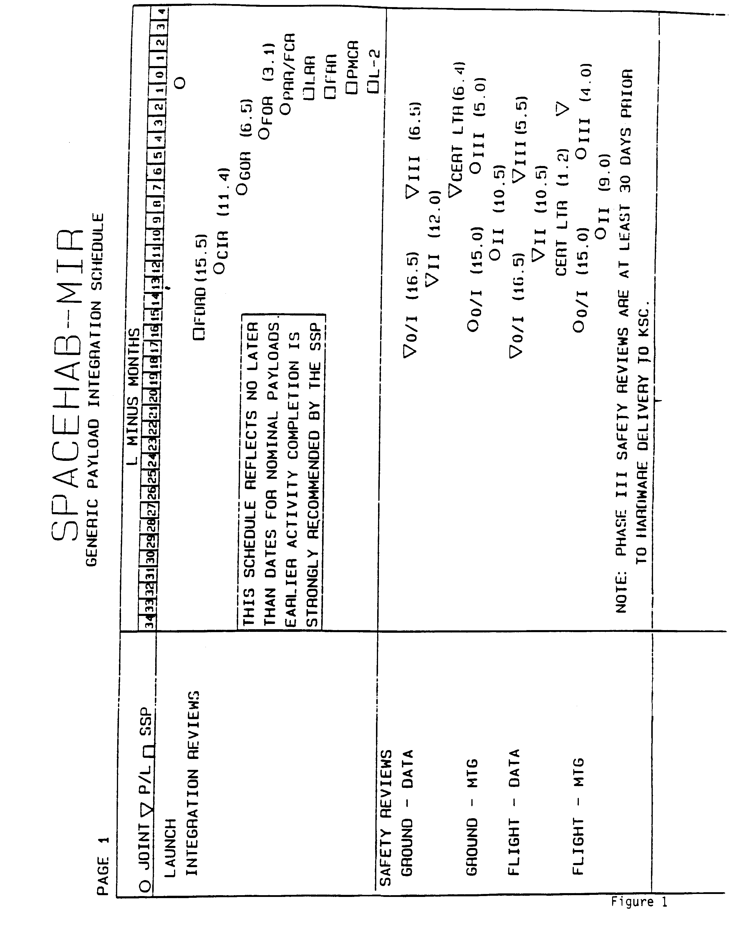
C-49
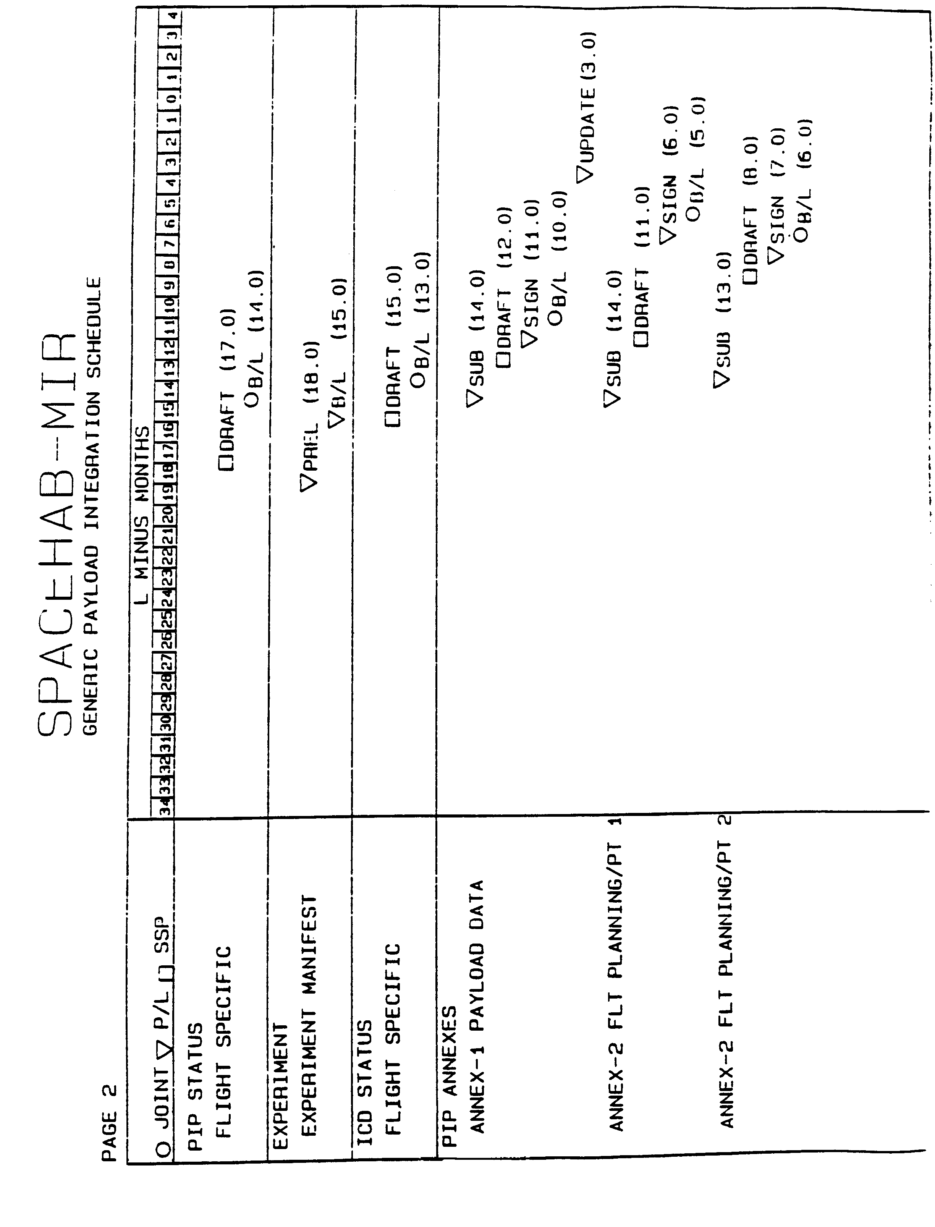
C-50
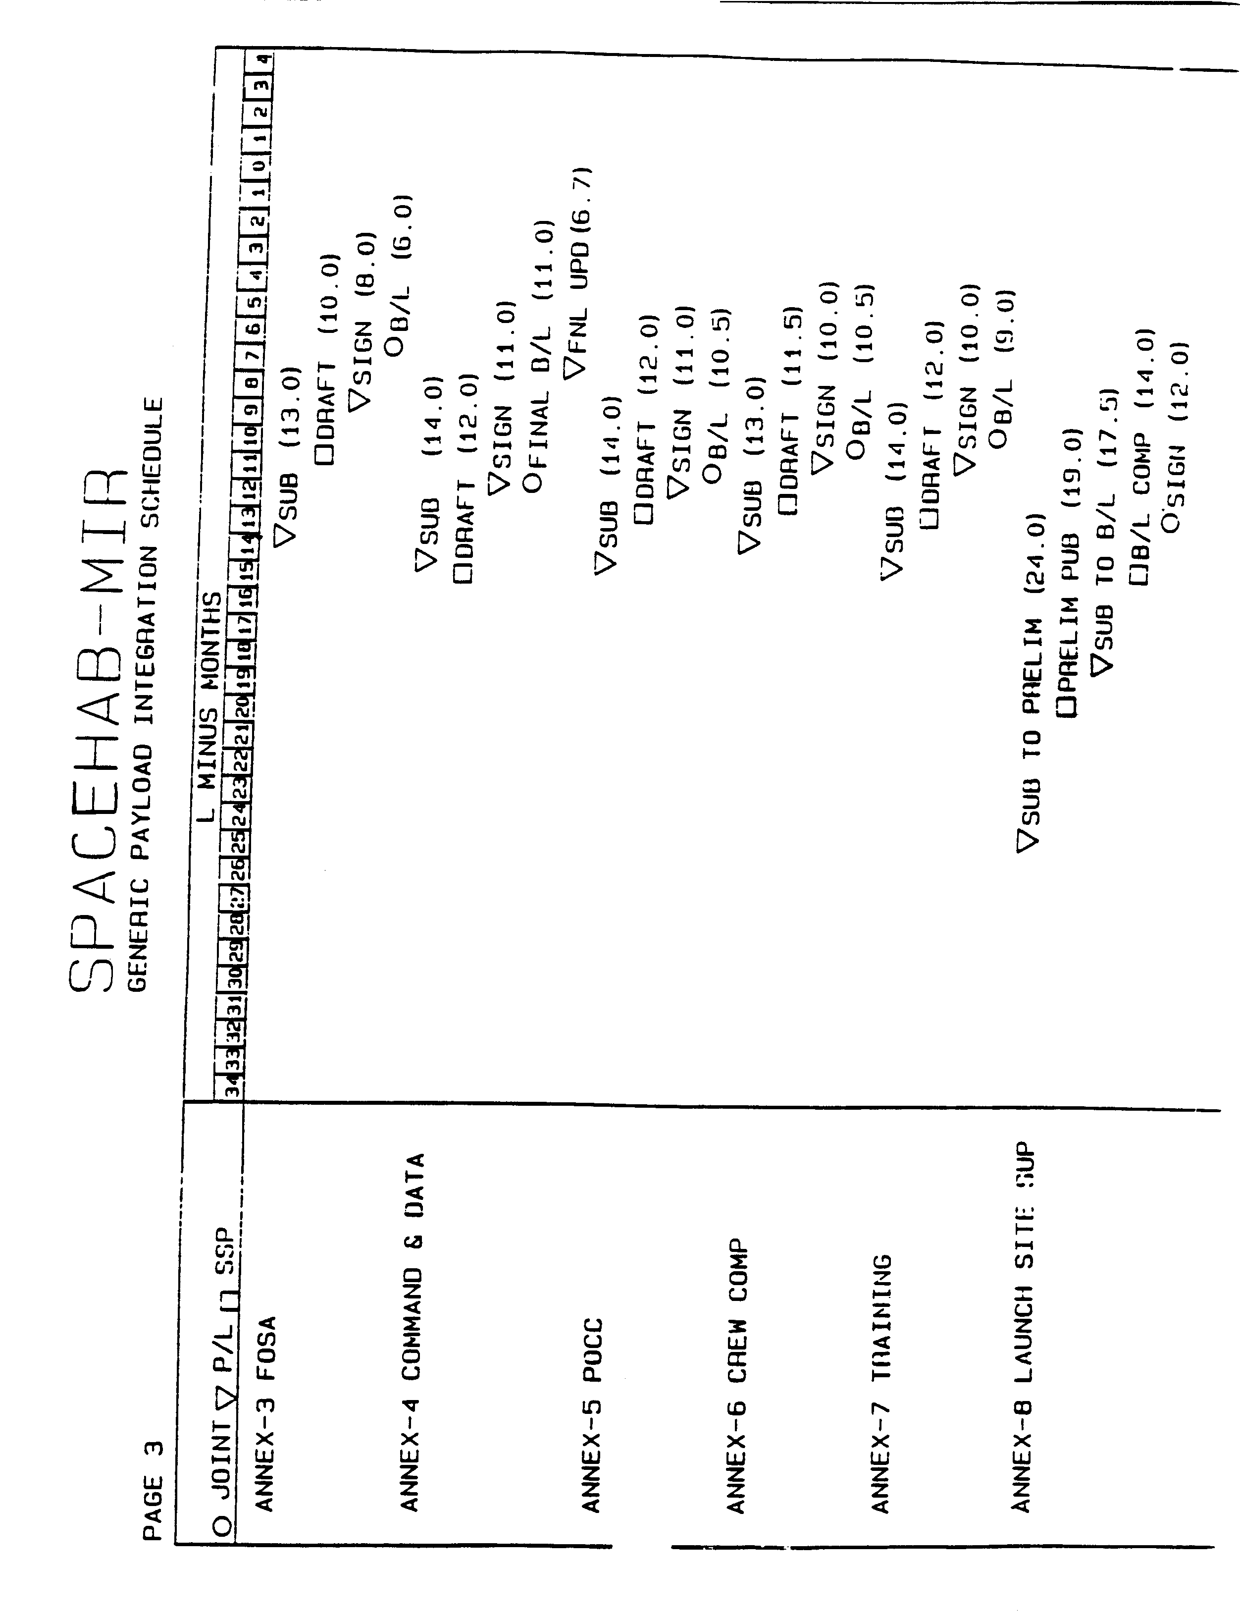
C-51
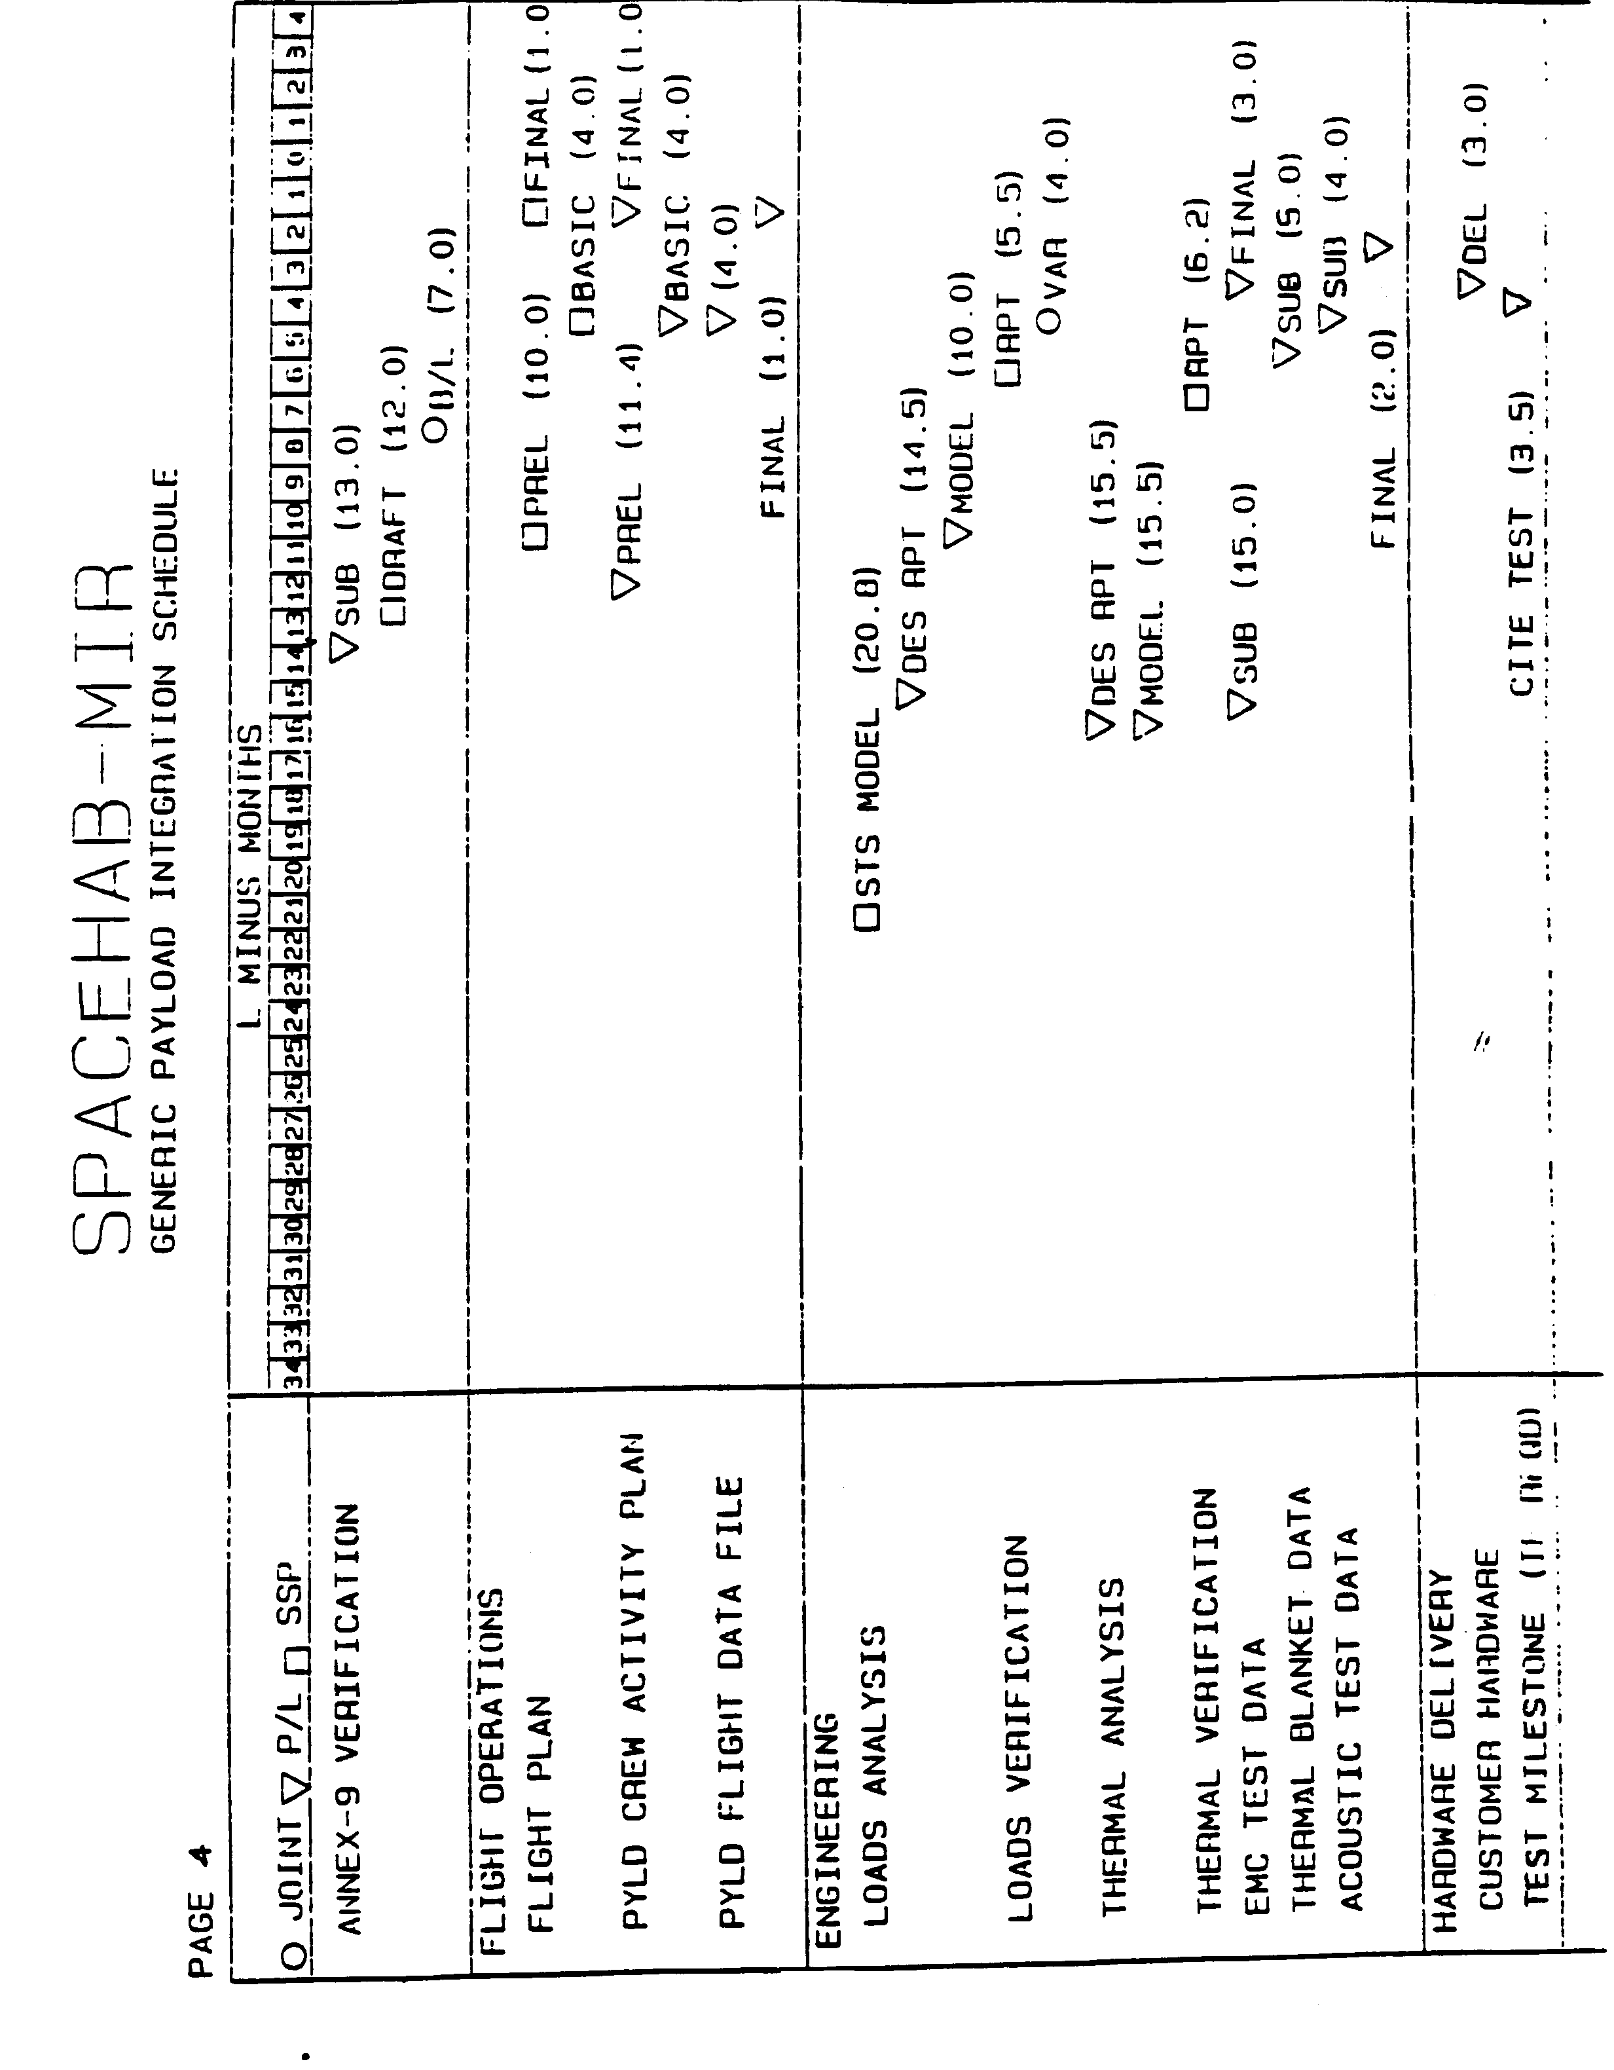
C-52
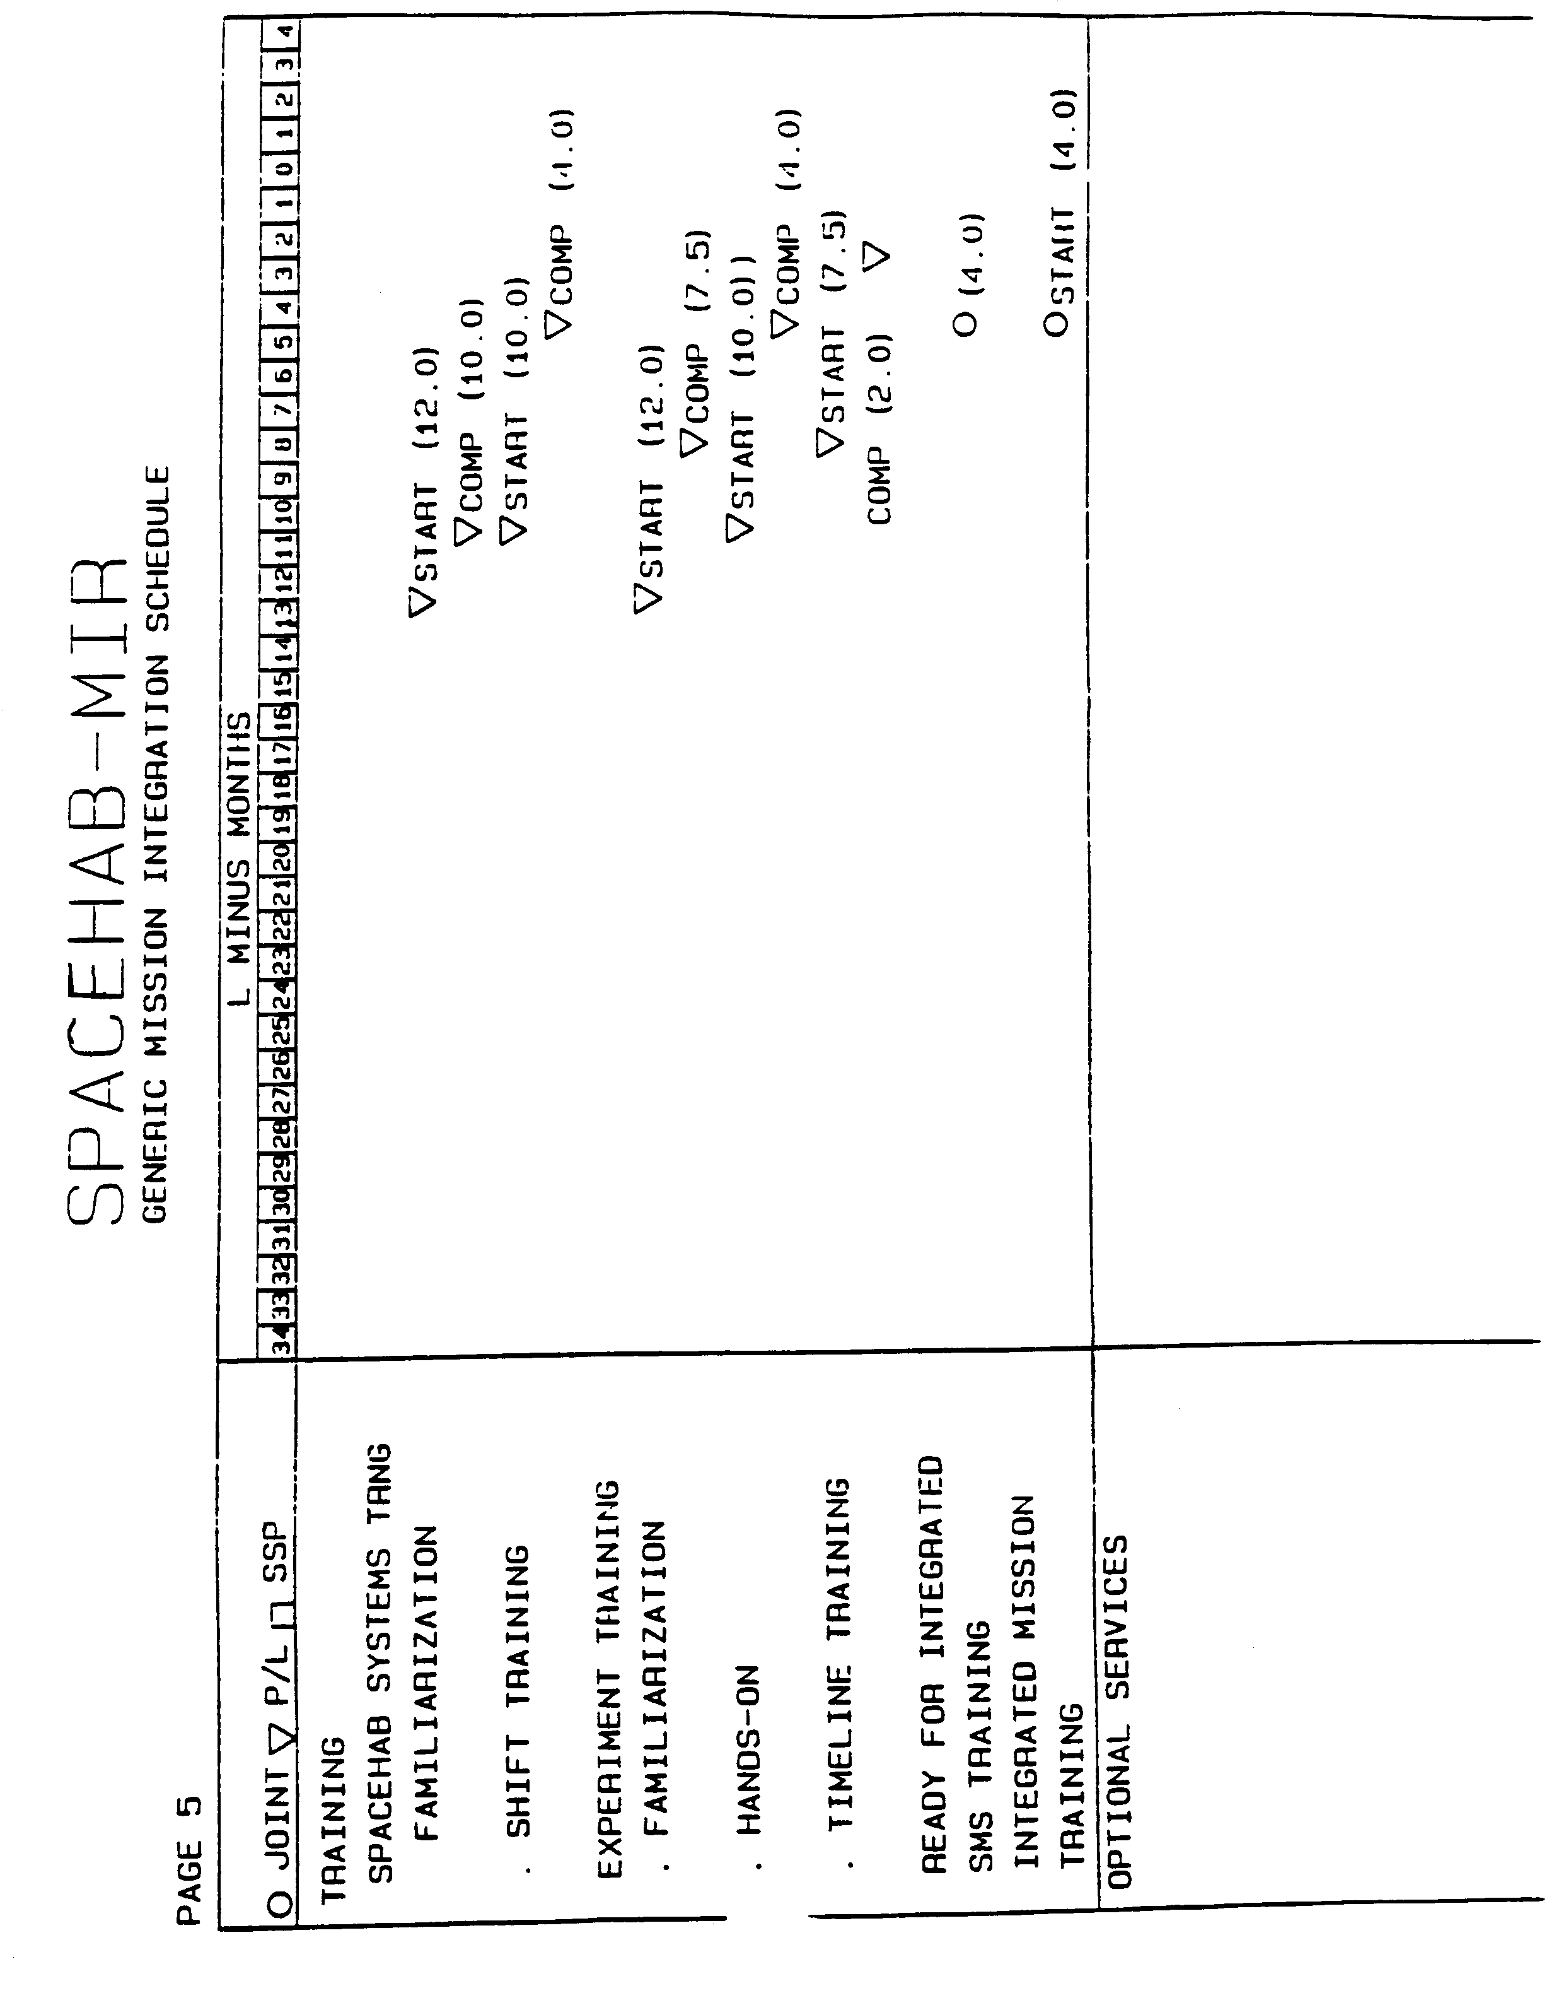
C-53

